For all VUMC:
Associated results for TB Skin Test administration and reading:
TB Skin Test administration will include Lot number, expiration date and education provided.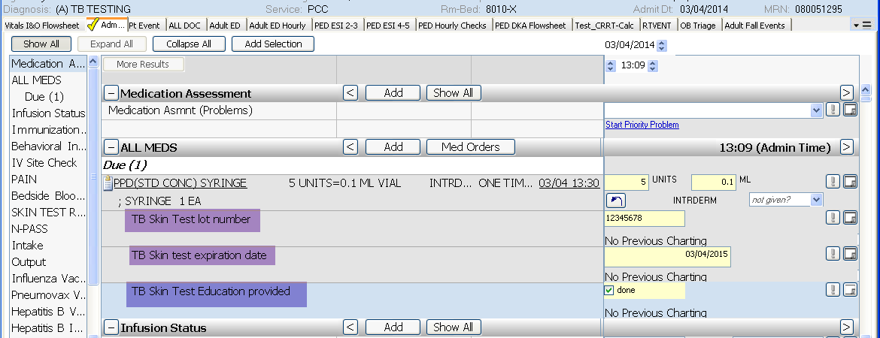

The TB Test Read reminder in AdminRx will include:
TB Test induration in mm’s. Any result above 5 will be red. Also, the Notification results will be present.
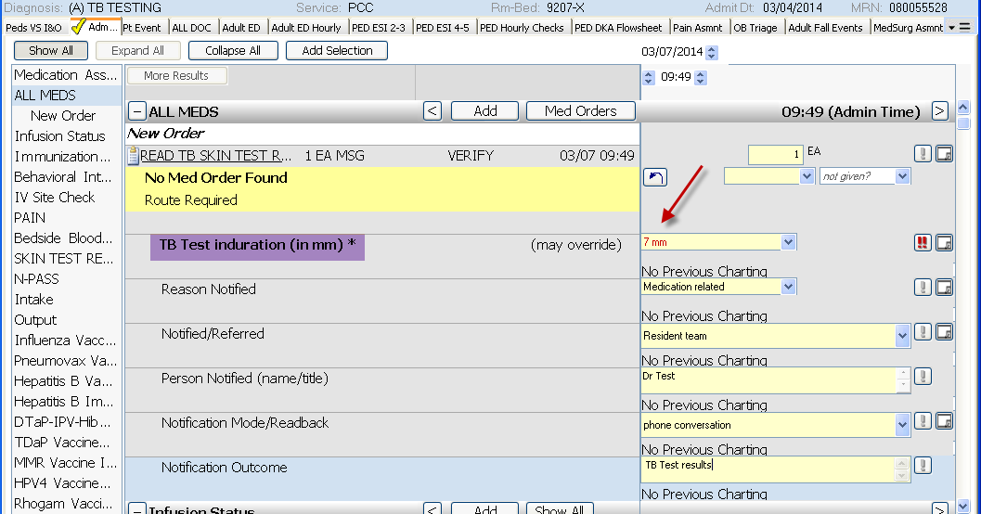

On the Pain Assessment, Cannot Self-Report Pain, Physiologic Cues:
Added “Elevated ICP” to the drop-down list:
