10/16/12
All VUH & VCH: Changes to Heparin documentation. ** SSS has separate education for this change***
IV Med Drips > Heparin now has “hold” and “stopped” as options in the dropdown
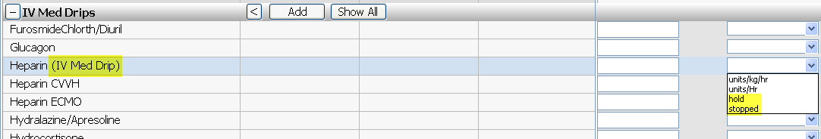
Intakes > Heparin (IV Med Drip) is now also chartable under the Intake section
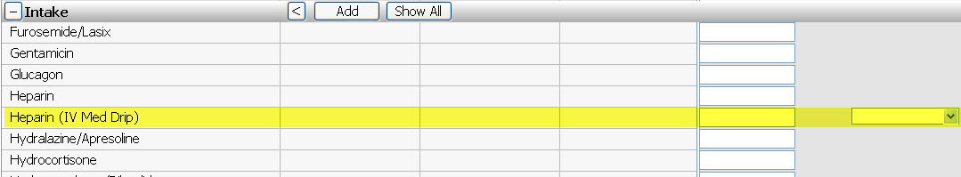

For Peds ED
PED ESI 2-3 and PED Hourly Checks > Psychiatric Observation – Two additional options under Observation Interventions “sitter @ bedside” and “police @ bedside”
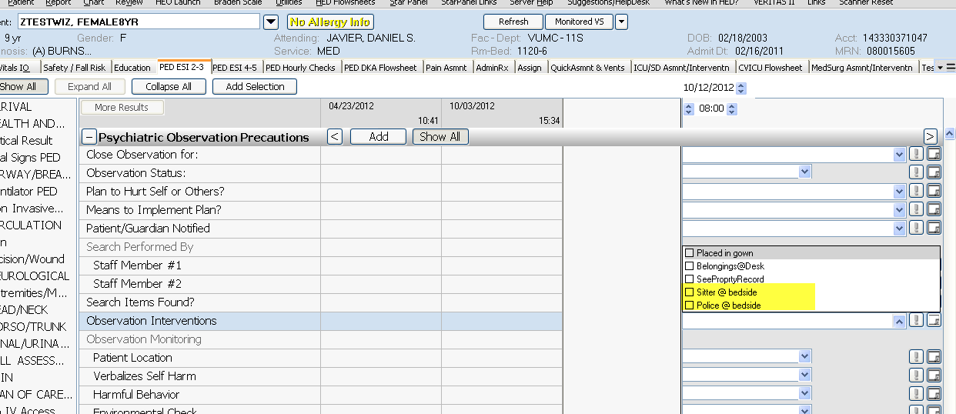

NICU request for Admission time.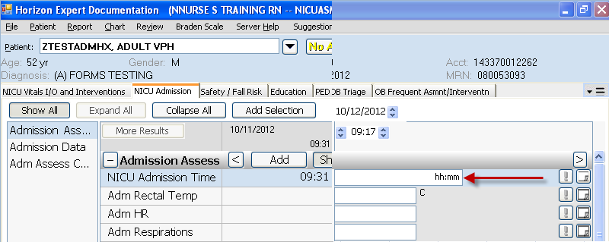
Newborn Nursery request for pulse ox spot checks at 24hrs age and at discharge.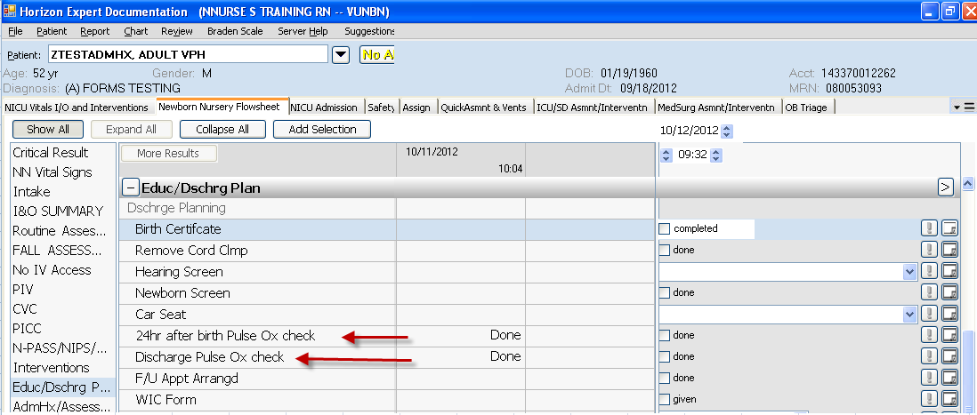

New Education tab- added the option of “Patient” and removed the Care Contact + patient.
