VCH only
Braden Q > Activity> added verbiage of “Too young to walk” to last options
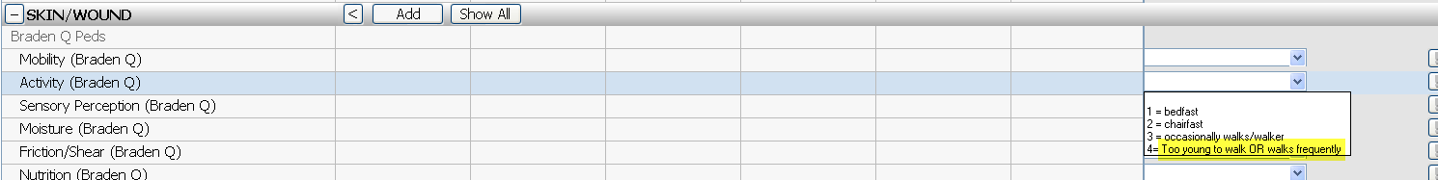

VCH/VUH
Positioning Care – updated hover text
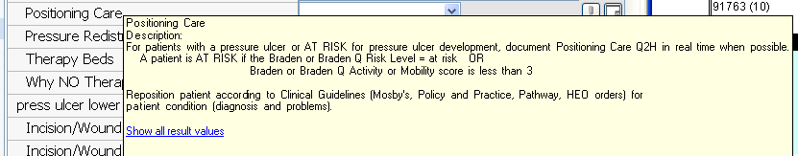

Incision/Wound Appearance – removed ‘approximated’ and added ‘healing’ to the dropdown list. Updated hover with ‘healing’ definition.
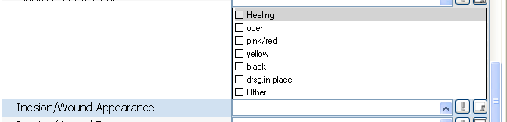

Incision/Wound Treatment – Added to options to dropdown list
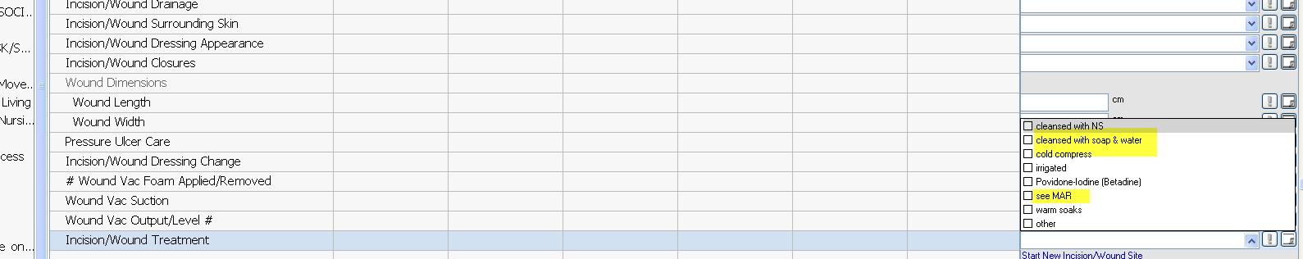
On Incision/Wound Dressing Change – added two more options to the dropdown list
