For 4MSC, 4EST, and 4NPL –
Postpartum Asmnt/Interventn>Breast – Breast Feeding Support Education has been added
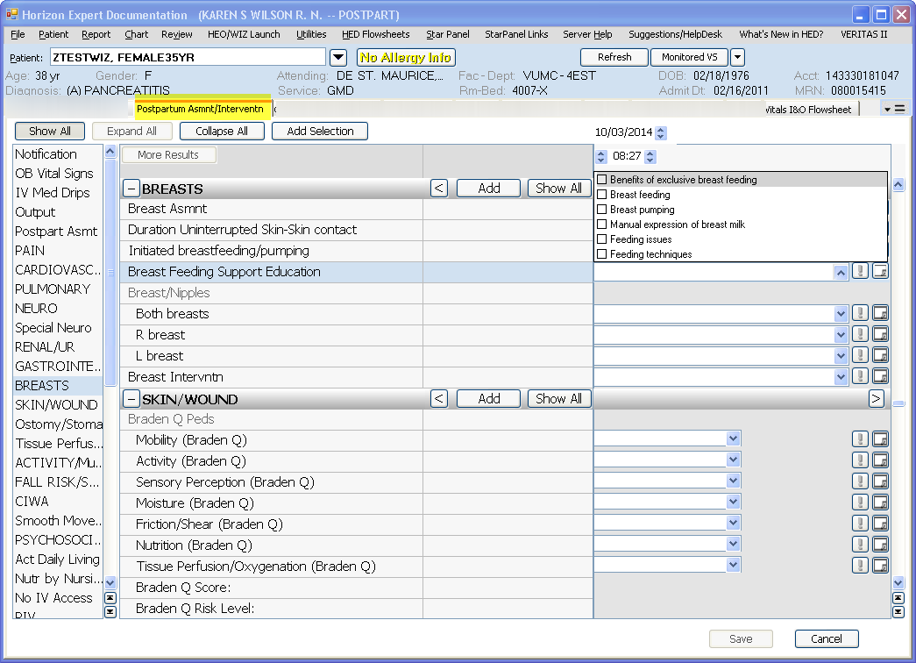

This is a shared field with the OB Education section in the Education Record
