**Changes to Safety section in HED Tuesday, June 25, 2013**

Assessment tabs - Fall Risk/Safety: We have changed the display name of Violent/Agitated behavior to “**Injurious behavior”**

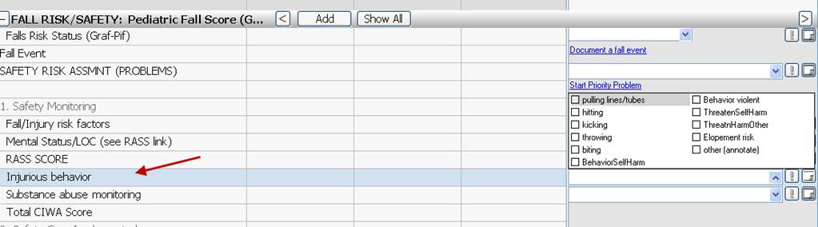

We have added a **new Charting field** in the Violent Restrain Cont/Disct. Discussion section.

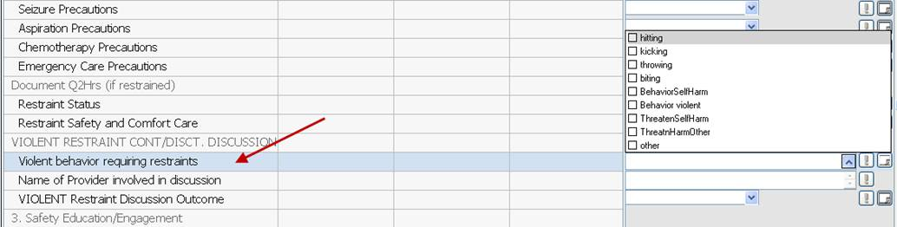

We have *updated the hover* in the **Name of Provider involved in discussion**

