The New tab called “Education” will go away for 9NSM. All of the new Education documentation has been moved to the original “Education Record” tab.
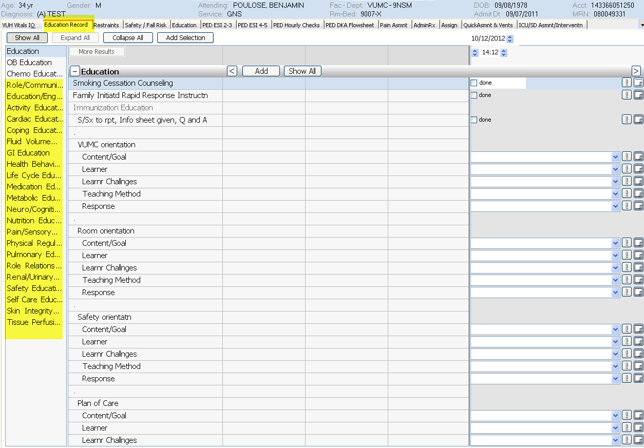
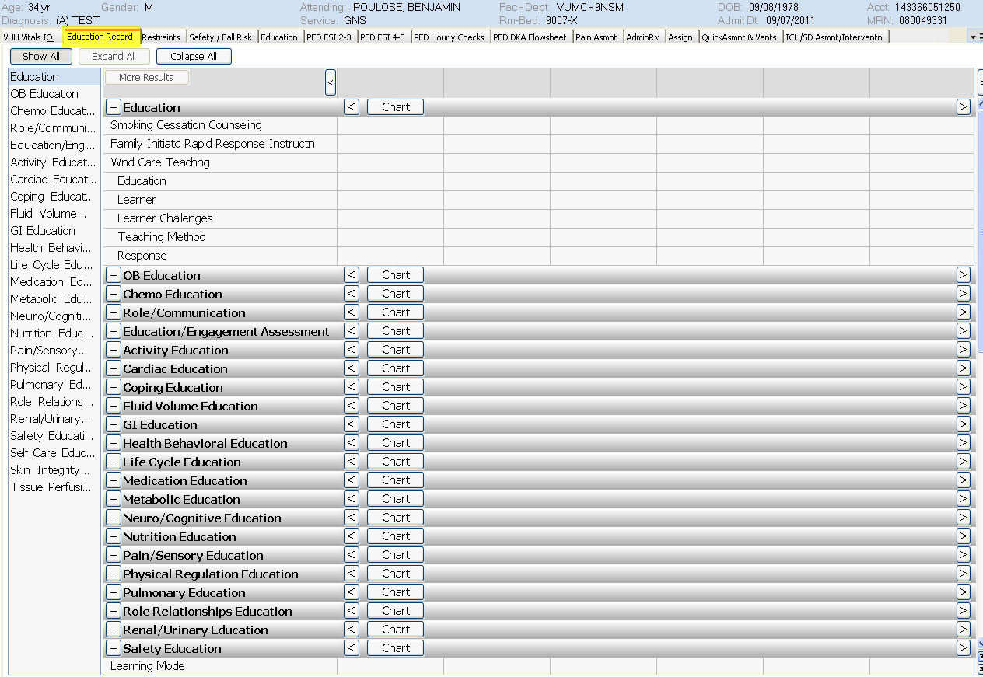

On the Restraint tab for the Roll out units, there will be two shared fields found between the Safety/Fall Risk tab and the Restraints Tab – “Restraint Status” and “Restraint Safety and Comfort Care”. The Roll Out units will retain Pt/Fam Education for Restraints and the VPH Only documentation will remain visible on the Restraint tab just as it is now.
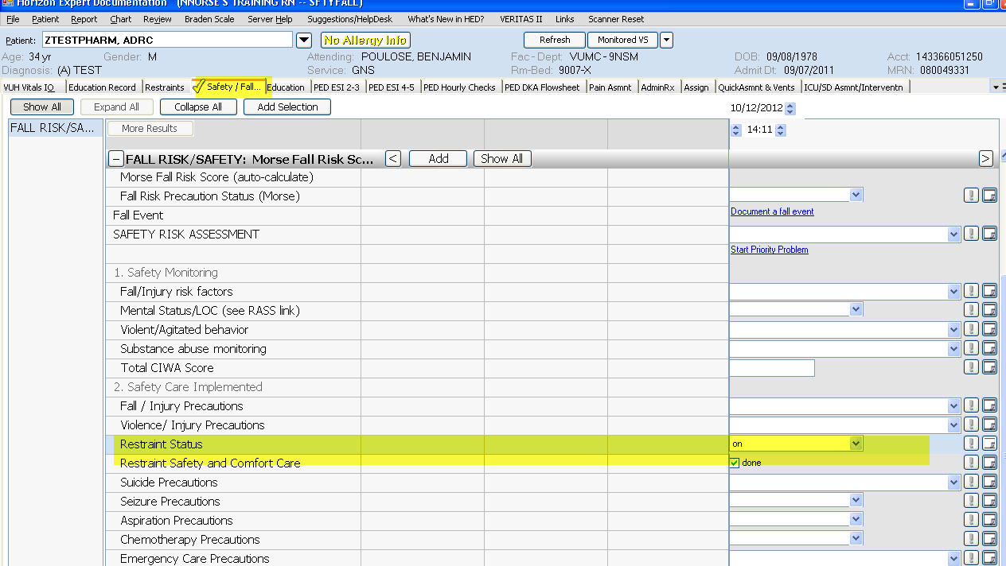
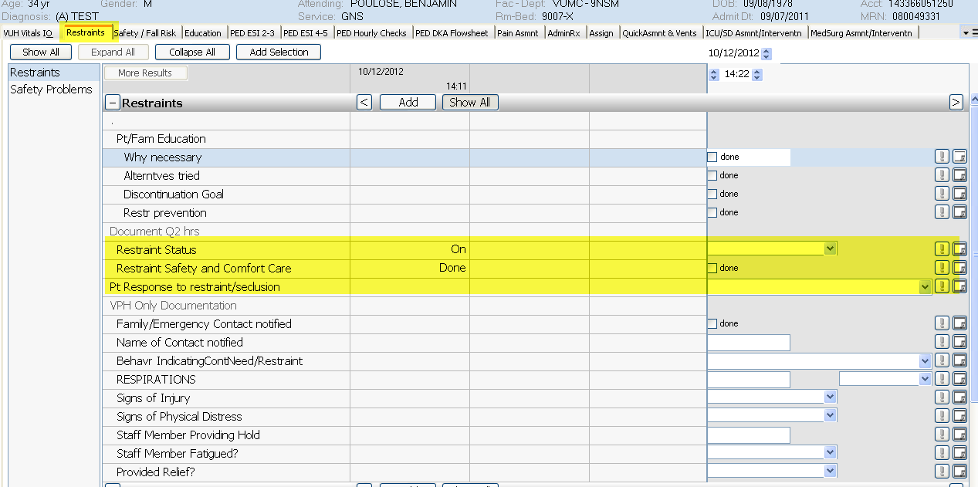

As the units roll out they will be added for CIWA documentation found on the MedSurg Asmnt/Interventn, ICU Asmnt/Interventn, and the VPH-Protocol tabs
