**Peds ED:**

PED ESI 2-3  >  HEAD/NECK  >  Added “ecchymosis” and “foreign body” to drop-down list for Eyes, Ears, Nose and Throat fields:

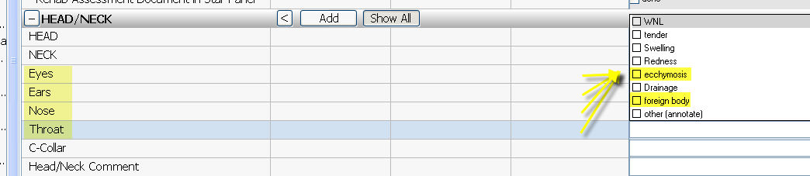

PED ESI 2-3 & PED ESI 4-5  > ADMIT/TRANSFR/DISCHARGE  >  Added a header to the Admission fields:

