Peds form
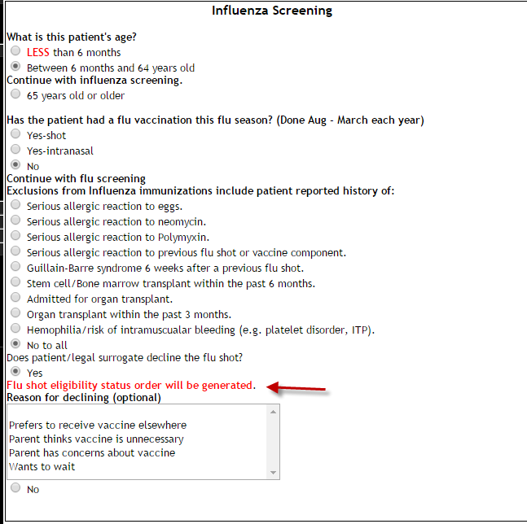
If the patient/family refuses the shot or not, a protocol order for influenza vaccine eligibility is generated in HEO as a reminder to providers.
No medication administration is scheduled.

