PEDS ED HED changes

For Peds ED-
PED ESI2-3> New section has been added just below RENAL/URINARY for Reproductive
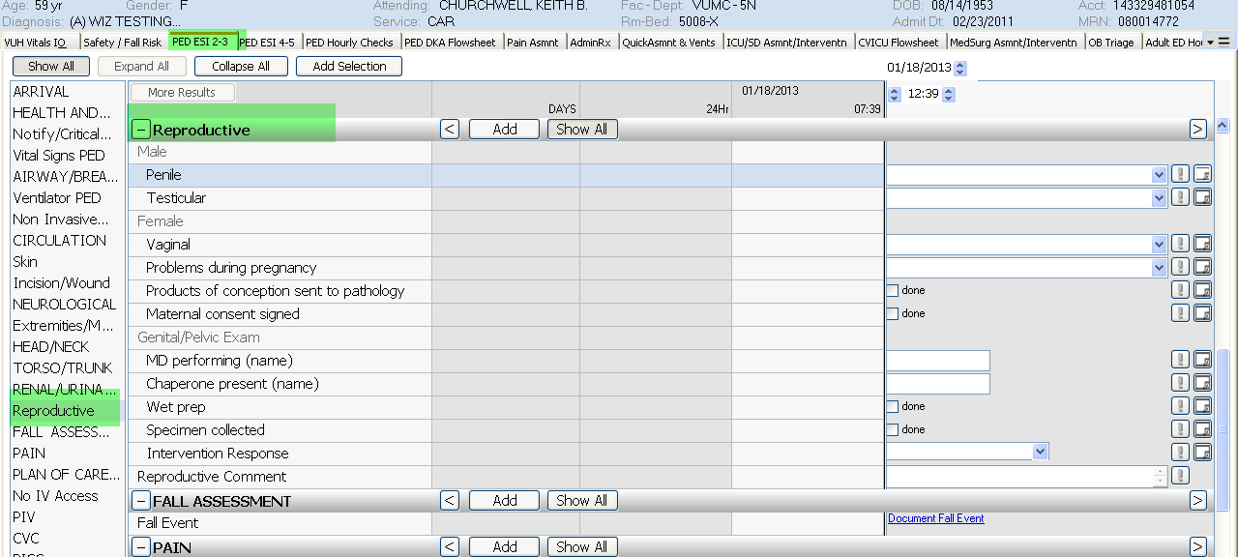

PED ESI 4-5>the Falls Assessment has been added just below the Assemnt/Interventn section
