Link to the Immunization record has been removed from the Adult and OB Nursing Admission histories:
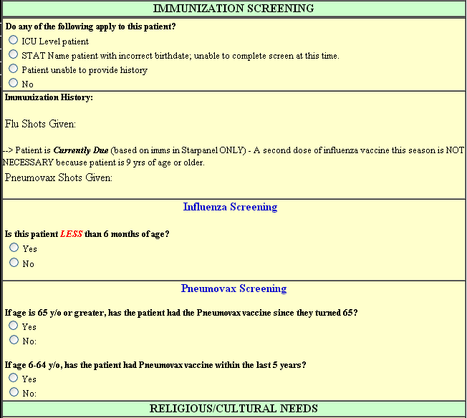
The Immunization Record can still be accessed from this link in Starpanel:
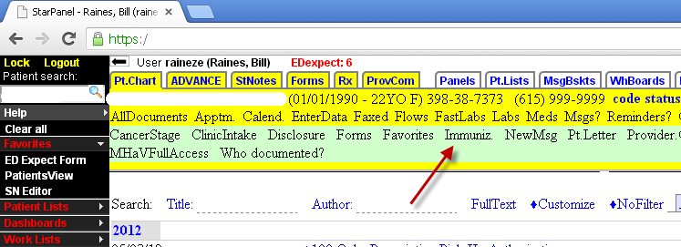

Pneumovax screening is collapsed until one of the patient age questions is checked:
6-64 years used in the example.
