Updates to Nursing Admission history forms:
All forms:
Added text regarding notification that a protocol order is generated when patient has a home medication pump in use:
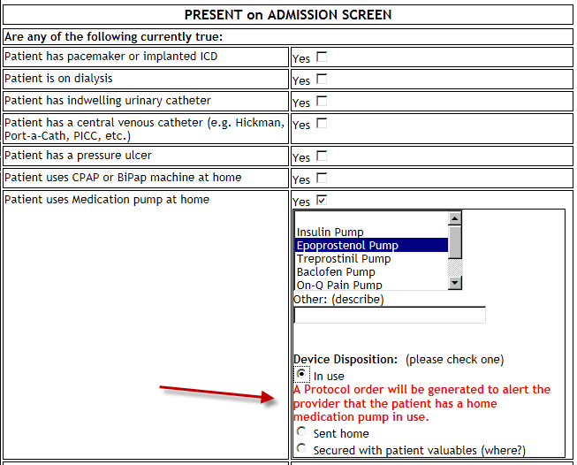

Added text informing nurse to enter Patient contact information in HED:
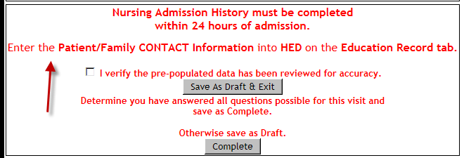

Adult, OB and VPH forms:
Added text informing nurse what to do if patient is uncertain what type of pneumococcal vaccine has been received:
