**New Flu Screening section on Admit History in place now 12/14/12. Please print, post and share.**

Over the last 24 hours, there was a request from Infection Control to add back to all Intake Forms Flu screening questions. These changes have been made and they are now in production for all of the Inpatient Admission History Forms.

This new section is located between top section and current TB exposure question and the Legal Documents section.

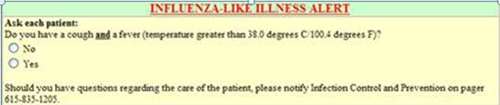

If they answer “Yes” to the Flu symptoms question, the box expands to show directions for place blue mask and screen for influenza.

