HED change release scheduled for Wednesday 6.12.2013

NICU and NBN: the N-PASS, NIPS and NWI will now have auto-calculating scores. Ex:

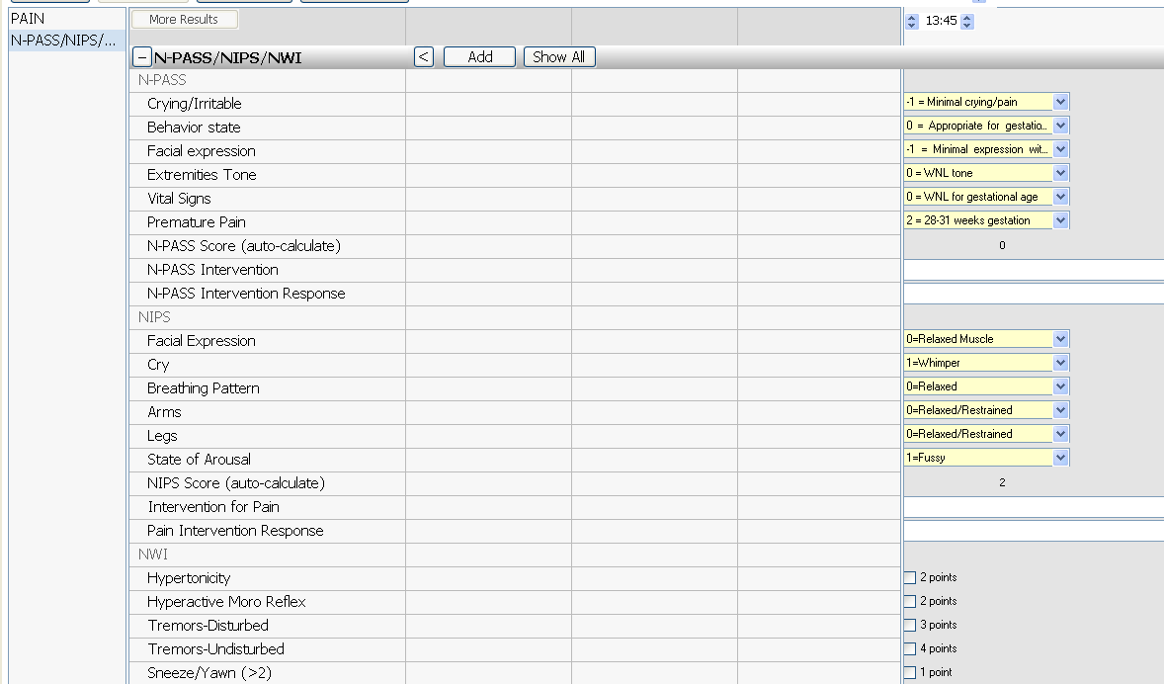

Newborn Nursery – Please note that the NIPS scale was re-built in order for the auto-calculation feature to work. Therefore, previous NIPS documentation will be viewable but no longer chartable:
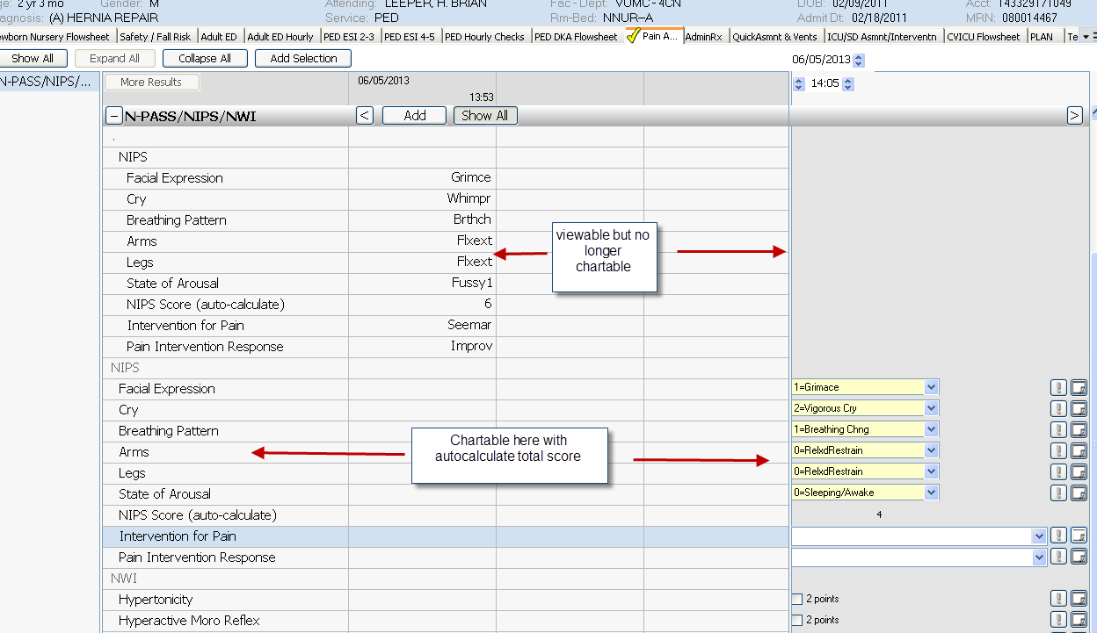
Old charting
New charting

