**NICU**

NICU Comment charting is also to be done under the Notification section, using the same house-wide fields.  Unique NICU Comment #1 and Comment #2 fields are being retired. Previous charting will remain viewable (under Notification).  NICU retains their unique Comment #3 field, which is now under Notification

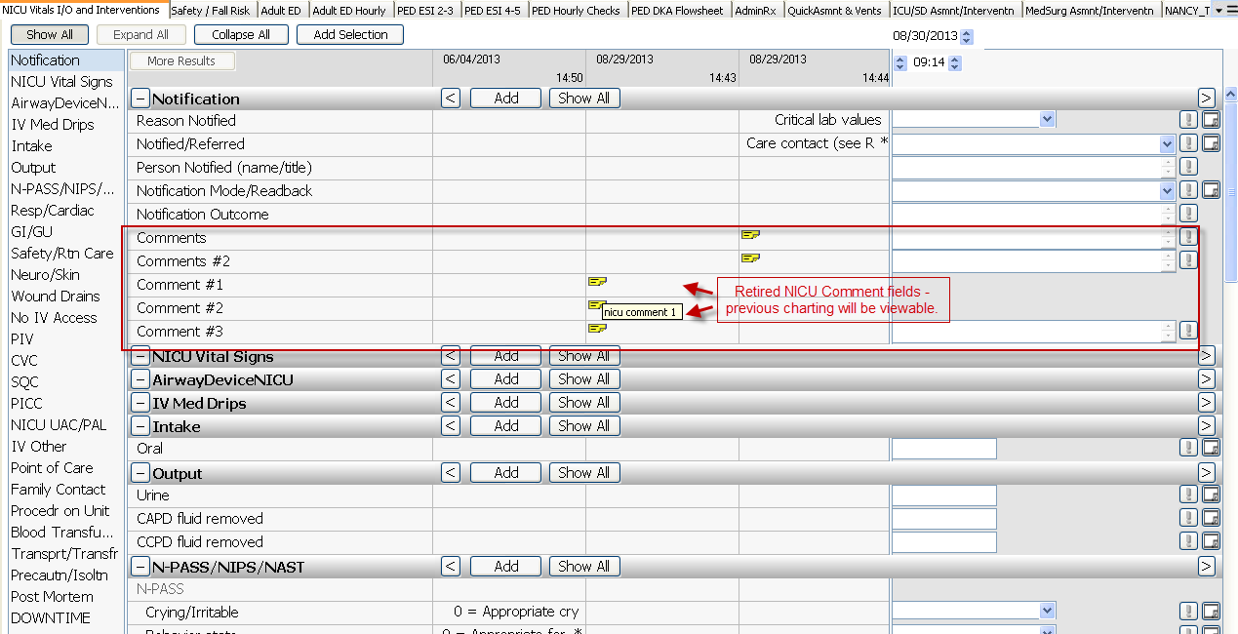

Added new vent mode PC-CMV+VG to the drop-down list.  
