Influenza season screening starts Tuesday, 09-01-15.
Updates to Influenza screening for 2015-16 season:
Additional option for patients 65 years of age or older.
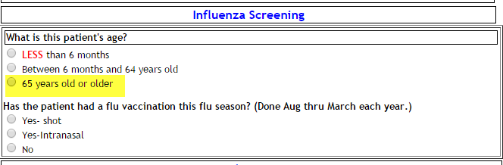
Screening questions remain the same as last year
Adult, OB and VPH forms
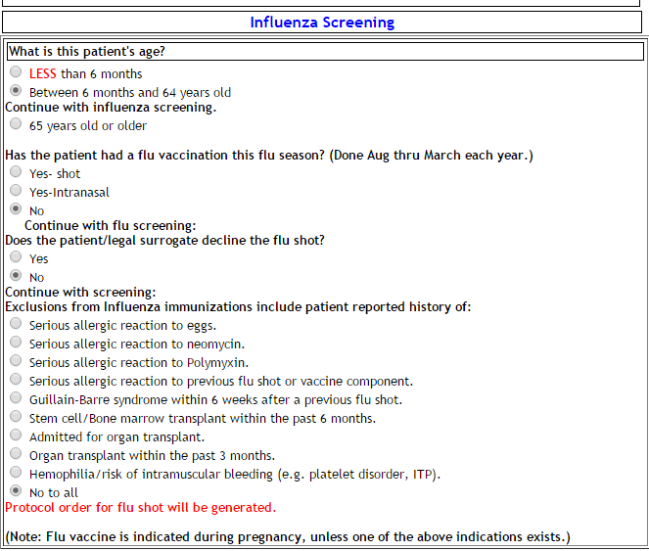
If the patient is between 6 months and 64 years of age, a protocol order for Standard dose influenza vaccine is generated in HEO and will be scheduled for the next day at 1000 AM.
If the patient is 65 years of age or older, a protocol order for High dose influenza vaccine is generated in HEO and scheduled for the next day at 1000 AM.

If the patient/family refuses the shot or not, a protocol order for influenza vaccine eligibility is generated in HEO as a reminder to providers.
No medication administration is scheduled.
Other functions remain the same.
If the patient reports already receiving the influenza vaccine, that date information is entered on the nursing admission history:
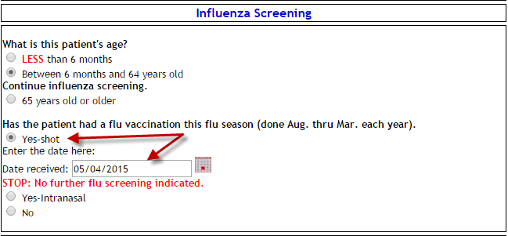
That information is sent to the StarPanel Immunization record
