HED updates for release for OB & CVICU

08-07-12

**On the OB Triage tab:**  
Update to the Domestic Violence screen to match the Nursing Admission history;  
  
 **Created new result where the display text reads “Do you feel unsafe at home”.**

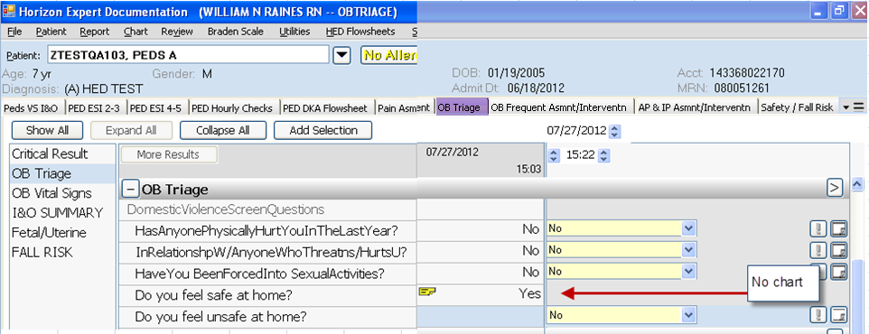

Original result that reads “**Do you feel safe at home” will be set to “No chart**”.

**For CVICU:**  
On the IV Med Drips class:  
 **Added Bivalirudin/Angiomax**  
