Attention! Changes to HED for October 9, 2012.
Please read, post and share with users.

All VUMC:
Pain > Pain Interventions > Added “nerve block”

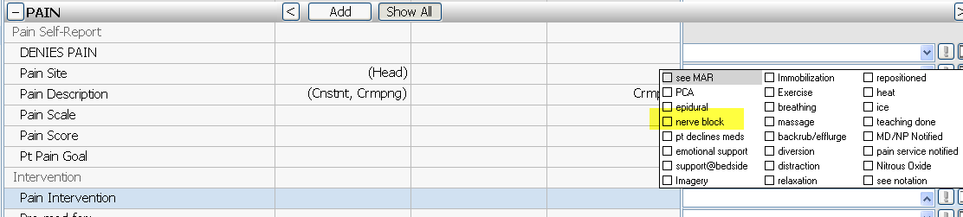

VUH and VCH:
Intakes > Added “TPN with Lipids”

