**For all VUMC –**

ASMNT tabs> CVC trended data > Gauge/Length – addition of 19g x 1 ¼

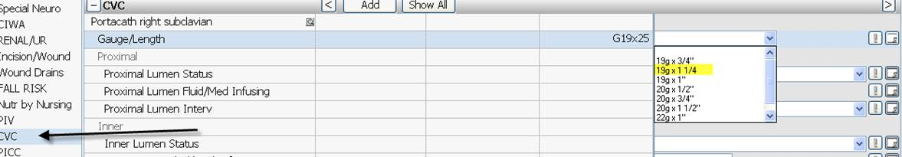

**For 11NM, 8S, 6A, and 6B**

Precautn/Isoltn section has been added to the Chemotherapy/Infusion tab

