**All VUMC - HED changes scheduled for 8.21.2012**

Assessment tabs > PIV trended data > Line Interventions – New to the dropdown list “aquaguard applied”.  Also please note that the options have been placed in alphabetical order.

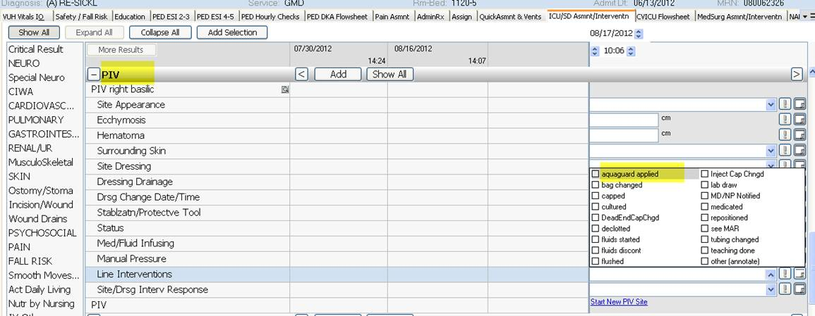

Assessment tabs > CVC and PICC trended data > Lumen Interventions (all Lumen Interventions) – “aquaguard applied” and “lab draw”  have been added to dropdown list.  Also please note that these options have also been reorganized in alphabetical order.

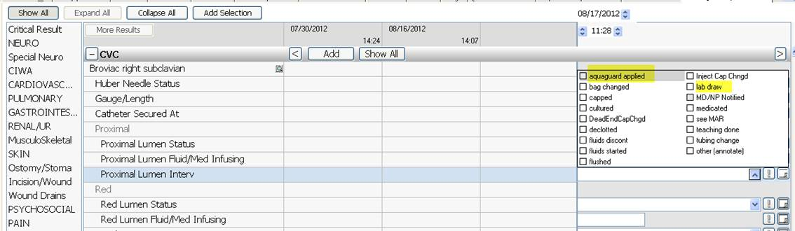

**For All VUMC except NICU and Newborn Nursery**

Pain >Pain Descriptor – “Contractions” has been added to the dropdown list

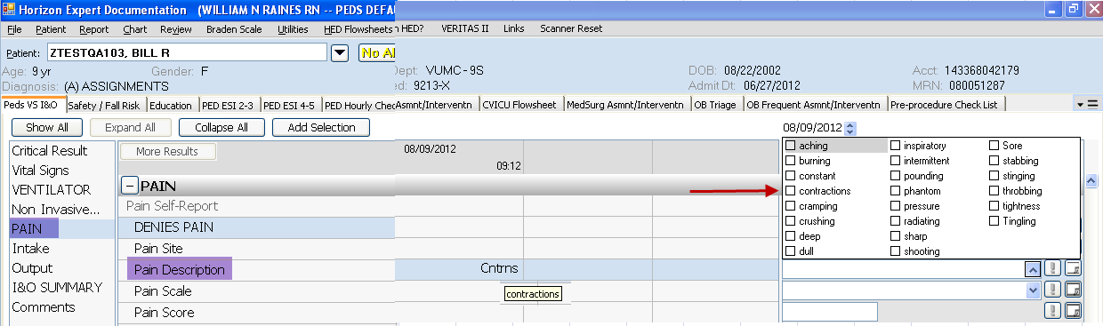

**For OB**

PostpartumAsmnt/Interventn >Breasts and OB Frequent Asmnt/Interventn > Postpart Asmt – New documentation for “Duration Uninterrupted Skin-Skin contact”

