Attention! Changes to HED for October 9, 2012.
Please read, post and share with users.

VCH > 5A and 5C:
PCCU Quick Asmnt > PCCU Quick Assmnt & Peds Asmnt/Intervention > Cardiovascular

Added new Alarm Settings options:
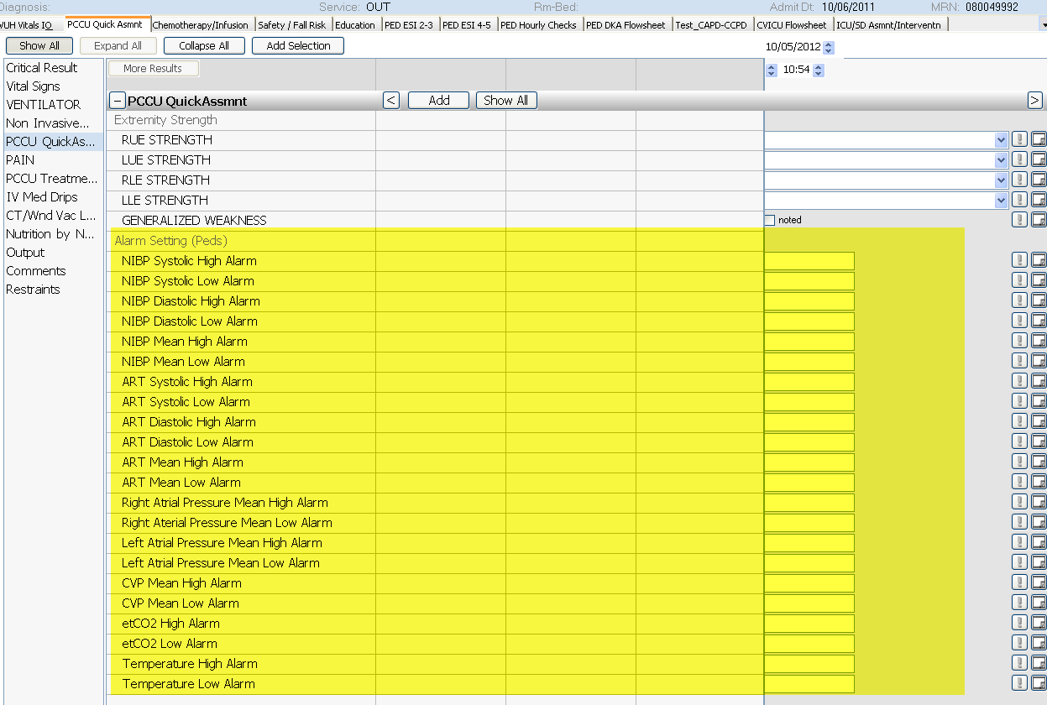

PCCU Quick Asmnt > VENTILATOR > added multiple new fields:
