Please note that the new **CARE PLAN Tab defaults to a 12 Hr / Shift View** so that in Review Mode, charting is condensed into 0700 and 1900 columns:

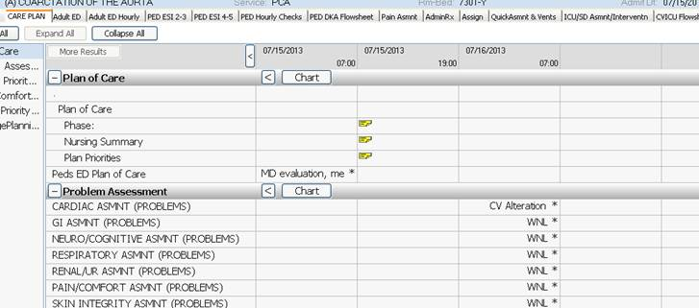

**In Chart Mode, Exact Time columns are seen:**

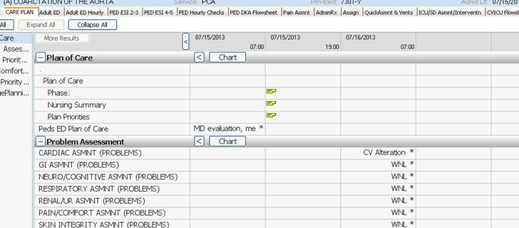

Users can also use **manually configure the tab in Review mode to Exact time by Right-Clicking:**

