**Attention!**

**HED Enhancements to be released 9/24/12.**

***Please Print, Post and Share!***

**HED AdminRx has been updated with 2 new results for Influenza and Pneumovax vaccine administrations:  
When a vaccine is in AdminRx, 2 results are added automatically:  
  
Vaccine lot number and Education:**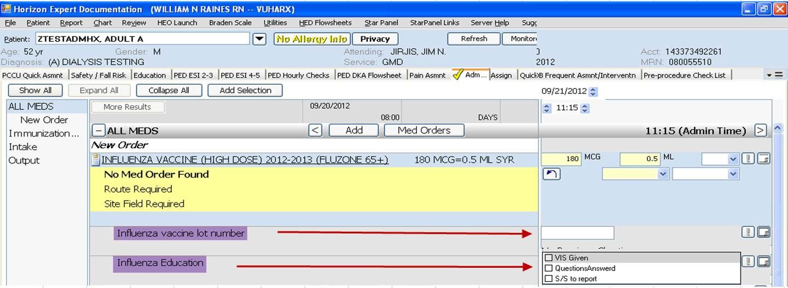  
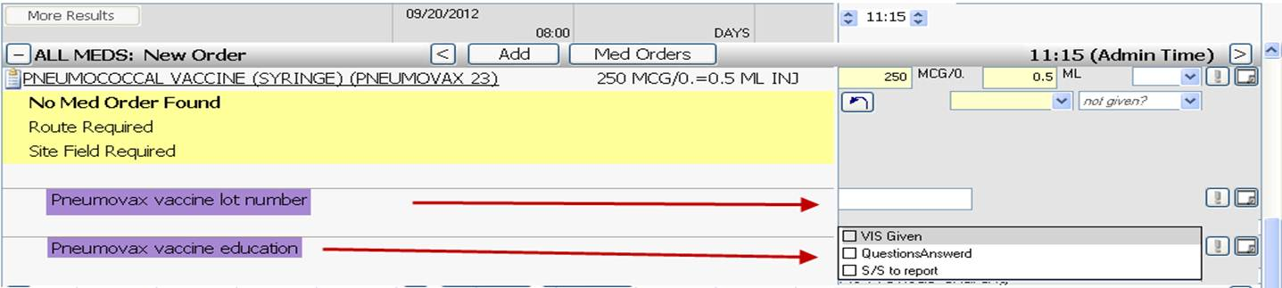

**These results will be mapped to the Adult Nursing Flowsheet in Starpanel.**