For VUH and VCH except NICU and NN:
Assemnt >Neuro>
The Glasgow Coma Scale and Pediatric Glascow Coma Scale are now auto-calculated. Any previous documentation of the manually-entered score will remain viewable but not chartable. The new auto-calculated field will display just below the previous field.
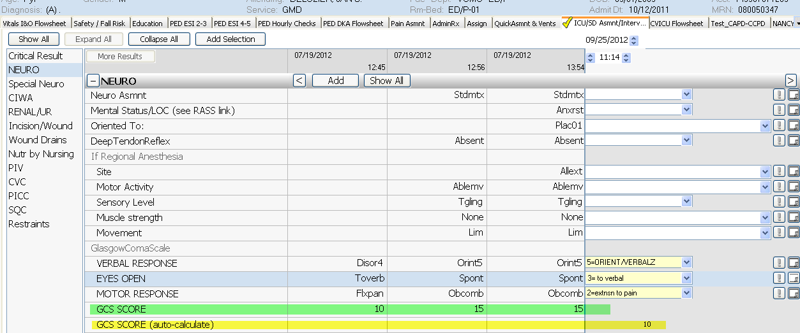
For all VUMC:
PAIN >
Pain Interventions> ‘MD notified’ has been removed from the dropdown list; it has been replaced with ‘MD/NP notified’
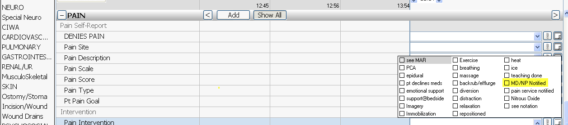
Pain Site > ‘R ear’ and ‘L ear’ have been added to the dropdown list
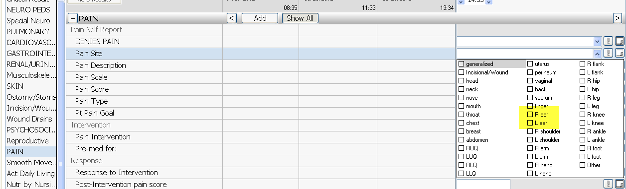

For 11NM, 6A, 6B, and 8S:
AdminRx>Infusion Status
‘Rate Increase’ and ‘Rate Decrease’ have been added to the dropdown list, and the list is now in alphabetical order
