For Units that are a part of the Nursing Documentation Redesign –
On ALL DOCS >Psychosocial All, ASSESSMENT > Psychosocial Assessment, and VITALS I&O>Frequent Assessments –
New charting fields of “Family Presence” – dropdown options of “family at bedside” and “patient alone”
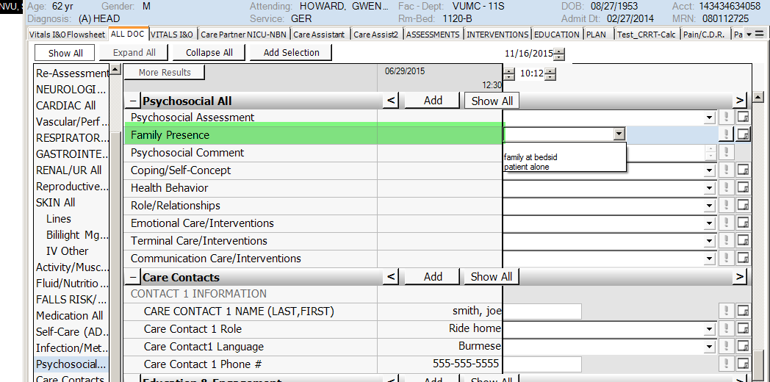
ALL DOCS>CARDIAC ALL, ASSESMENT>Cardiac Assessment, and VITALS I&O> Frequent Assessment- “return to NSR” has been added to the EKG Rhythm dropdown list
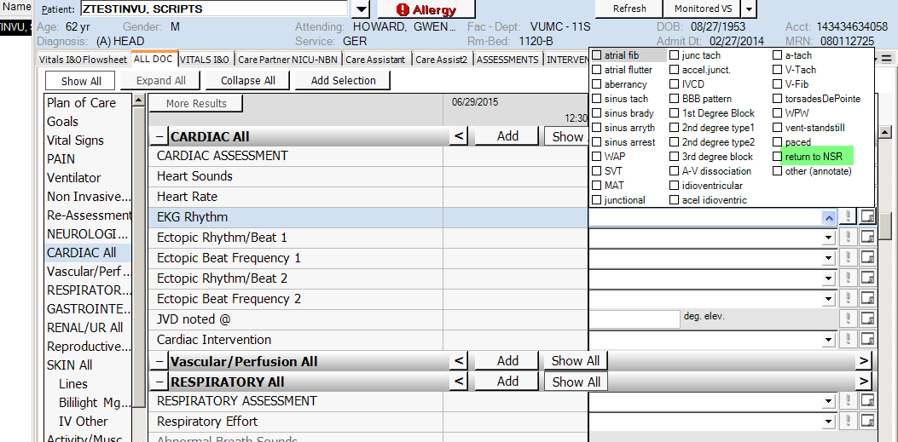

On ALL DOCS>Respiratory All, INTERVENTIONS > Respiratory Interventions, and VITALS I&O> Frequent Interventions
“suction- airway” has been removed from “Ventilator Interventions” and added to “Respiratory Interventions
