For the Adult and Peds Emergency departments, added “Teachback/Verblz Understanding” to the Teaching method drop-down.
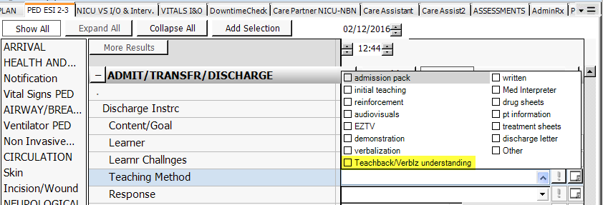

For 5N CVICU, added “Ventricular Assist Device” to the Cardiology Education drop-down. This will be available for all units
