For all VUMC - There is a new link which will take the user to the Eskind Library
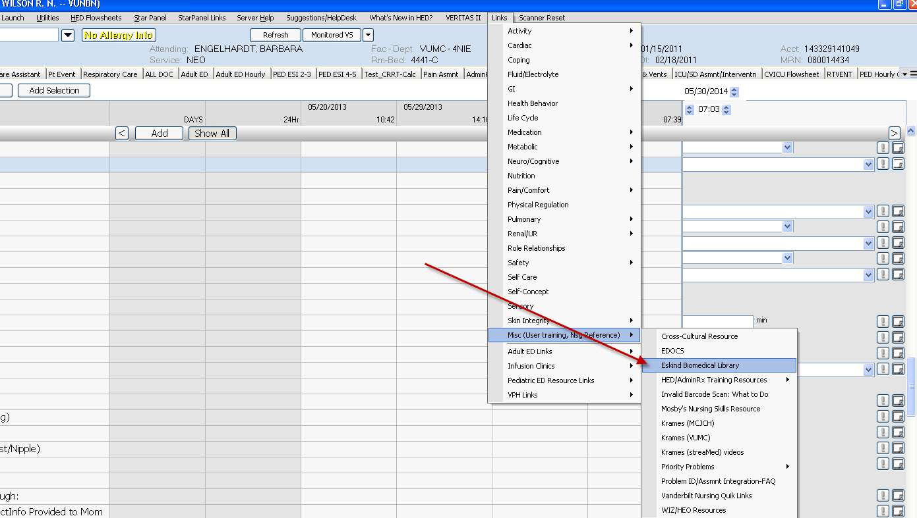

The Pulmonary/Respiratory Intervention charting fields have been standardized throughout VPH, Med/Surg, ICU’s, and Peds. If charting field is not seen, users may have to hit show all
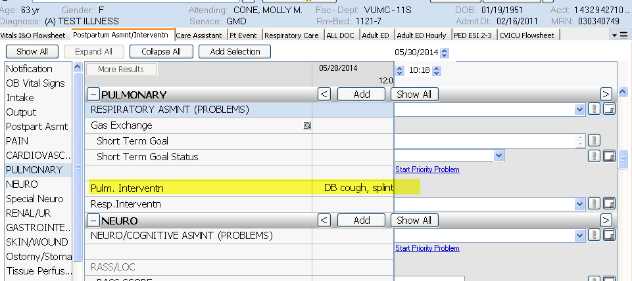

Coming Soon
