Education Record > Education/Engagement Assessment >Cardiac Education – two new options
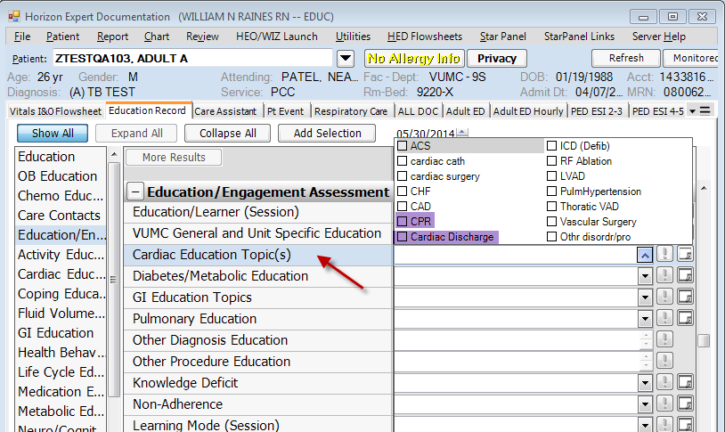
New charting field of GI Education with one option of “G-tube”
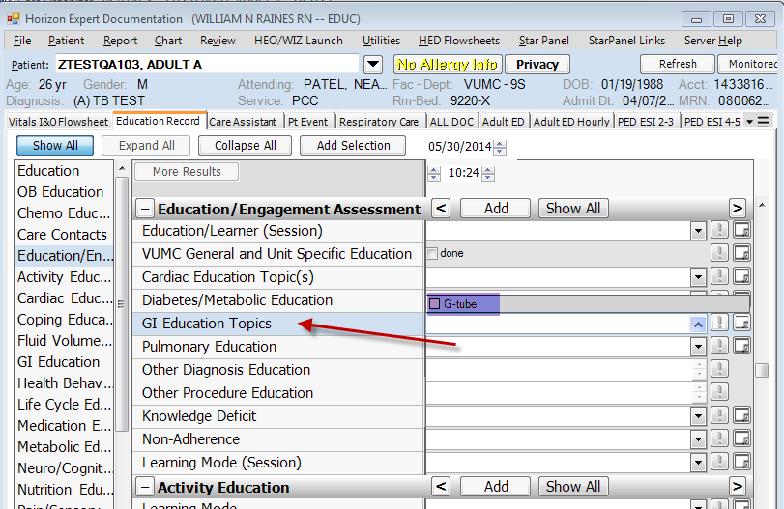
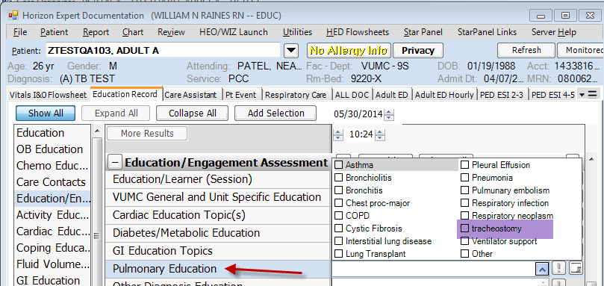
Added one option of “tracheostomy” to Pulmonary Education

Care Assistant Tab has the Notification section added to the top.
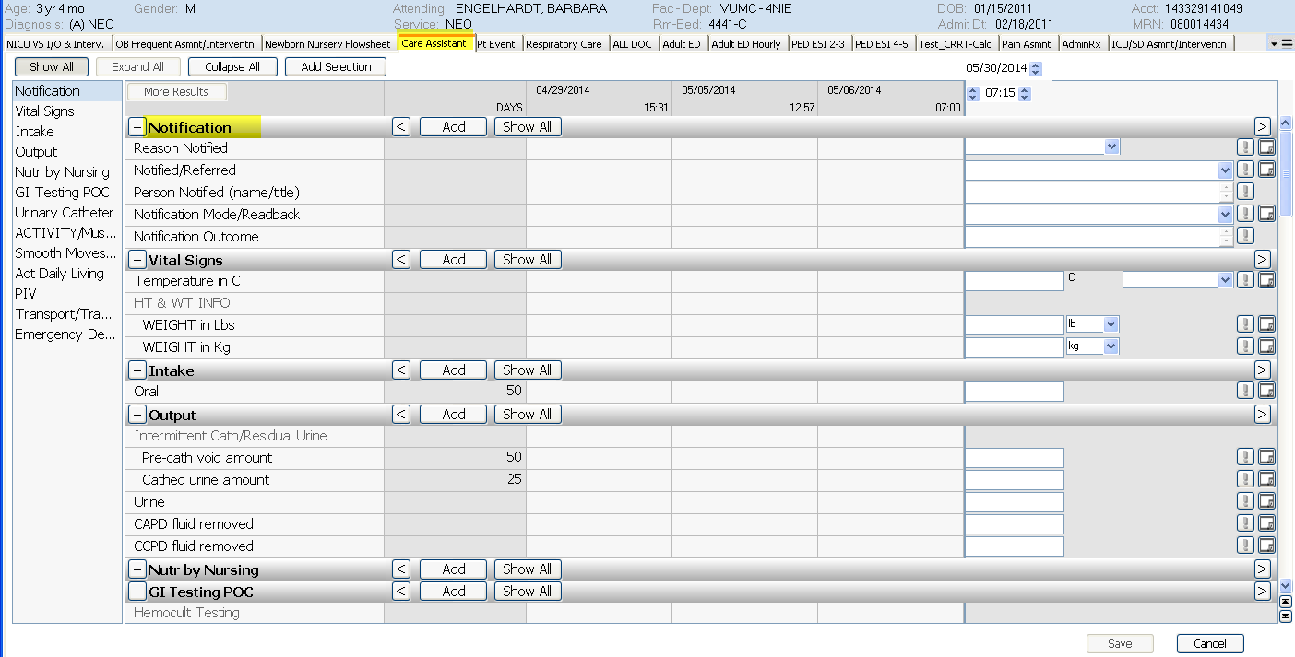

And, Incent Spiromtr and Resp. Interventn has been added to the Act Daily Living section
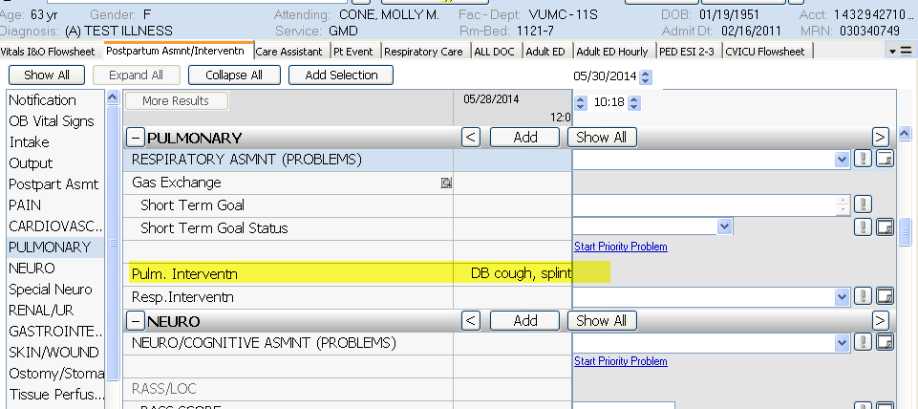

The Pulmonary/Respiratory Intervention charting fields have been standardized throughout VPH, Med/Surg, ICU’s, and Peds. If charting field is not seen, users may have to hit show all

For all VUMC - There is a new link which will take the user to the Eskind Library
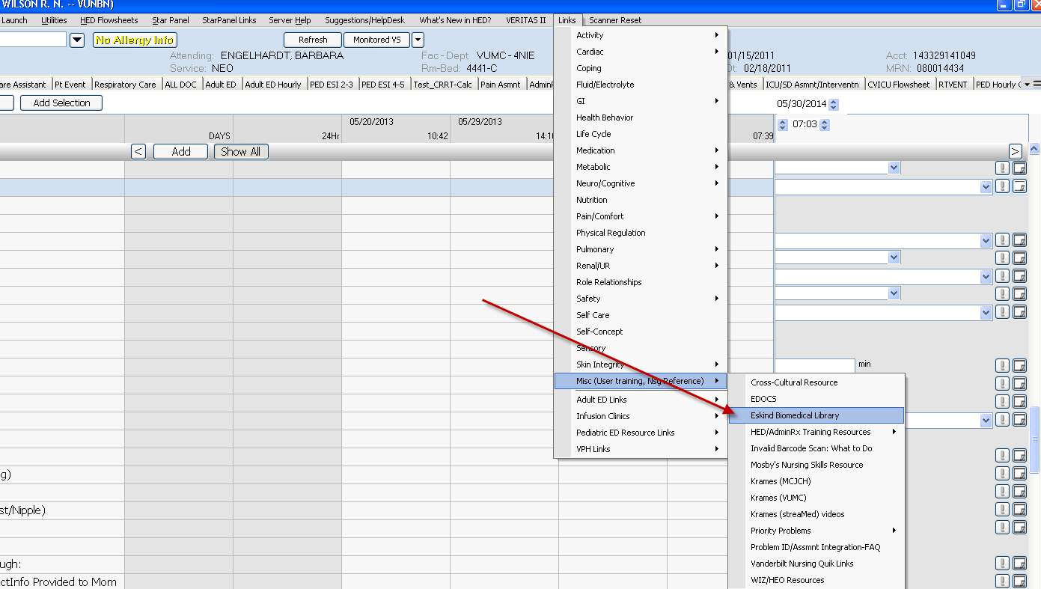

Coming Soon

