NICU and NBN have a new charting field of “Safe Sleep”.

NICU Safe Sleep is located on the NICU VS/I&O tab -> Safety/Routine Care first documentation field

NBN Safe Sleep is located on the NBN Flowsheet ->Interventions-> below Infant Location

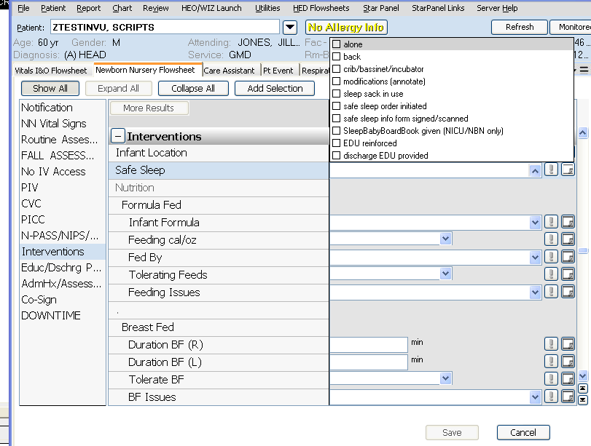

Shared with NBN and the hover has detailed explanation – NBN Flowsheet > Interventions -

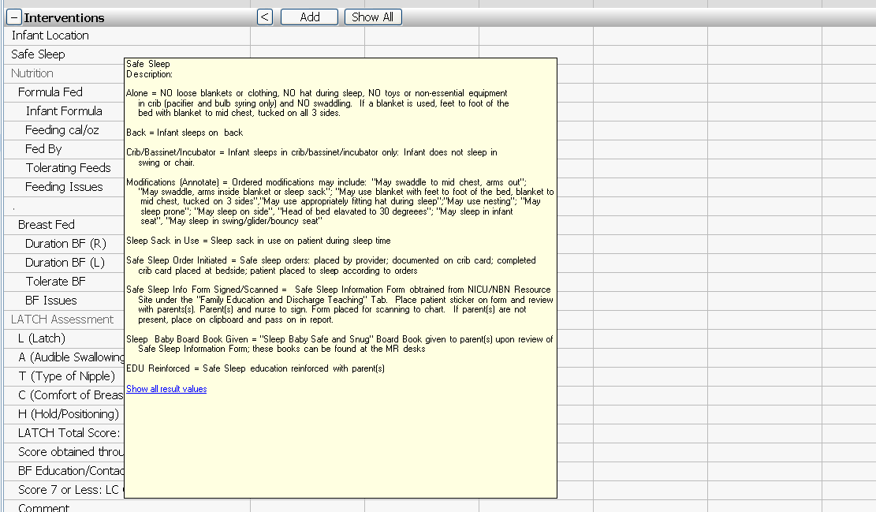

For all VUMC - There is a new link which will take the user to the Eskind Library

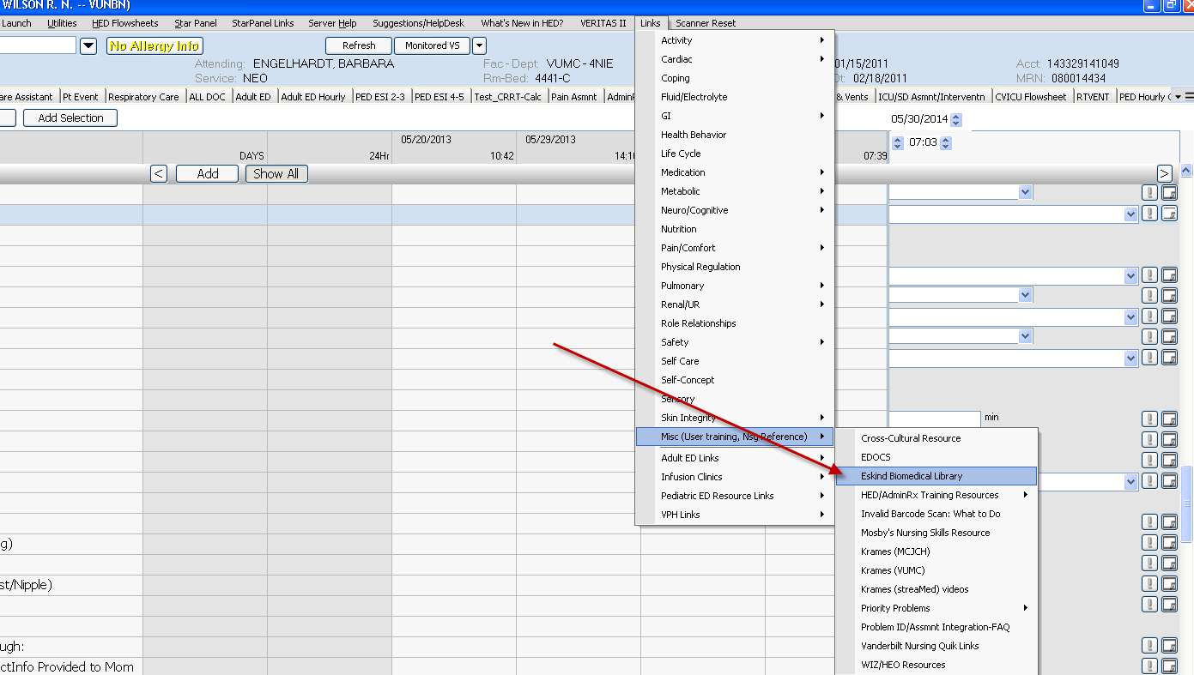

Coming soon

