**Please these additional changes to HED that will be implemented tomorrow.**

**For all VUMC**

Assessment tabs>Skin/Wound>Wound assessment trended data>Incision Wound Dressing Change – “drsg. reinforced” has been added to the dropdown list

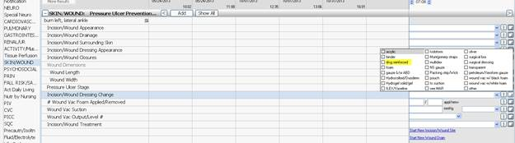

**For VUH and VCH the following changes have been made to the Education Record tab**

Education Record>Activity Education – There is a new option for “Energy Conservation Education”

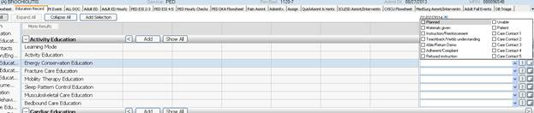

Education Record>Fluid Volume Education – “Hemodynamic Care Education” is no longer chartable. Any old documentation will be viewable.  Also there are three new options available, “Hydration Control Education”, “Intake Education”, and “Output Education”.

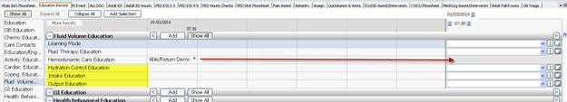

Education Record>Cardiac Care Education – an additional option of “Bifold given” has been added to the dropdown list

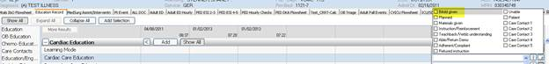

**For Med/Surg, OB, and ICU Asmnt tabs in VUH**

Assessment Tabs>Cardiovascular section – New section has been added “3. Cardiac Education” which contains shared charting fields from the Education Record

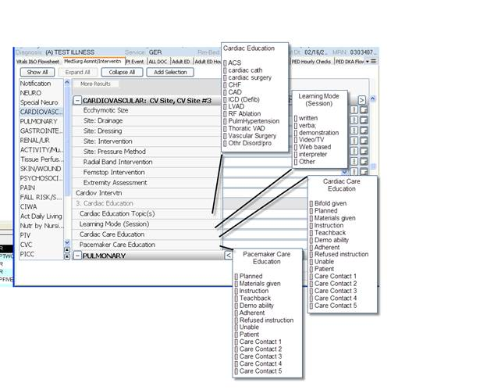

**Also note that on  On Wed, 1/8/14 the following change will be implemented in Medipac**

**the unit 11NM will be removed and replaced with the unit 11N.  This change will be implemented at approximately 2000 on Wed.  Staff will transfer exisiting patients in 11MN bed to the new 11N location and beds.  Thereafter, any admissions or transfers will need to utilize the 11N location in meidpac.**