For Newborn Nursery: Updates to Parent Education and Discharge section. New fields are highlighted. Previous documentation will be visible, not chartable.
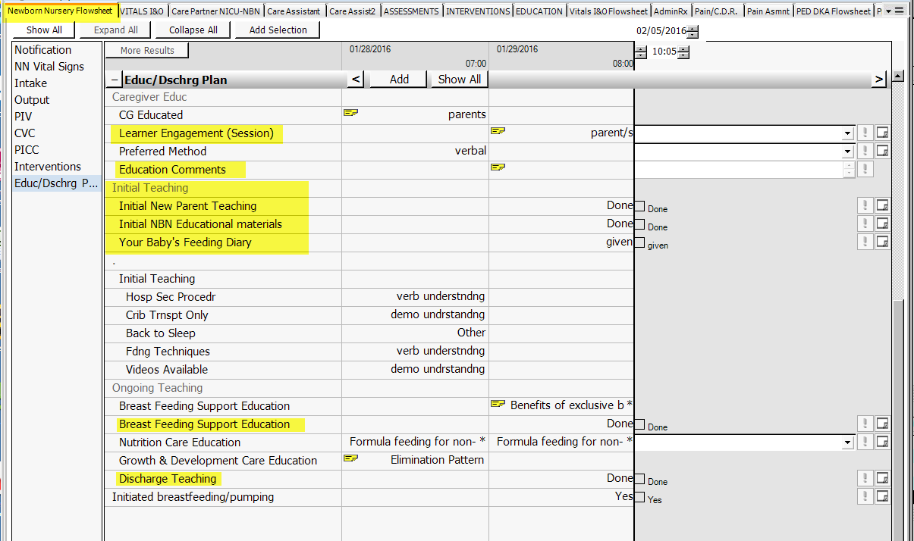

Each new result with a checkbox will have hover data to detail what was taught or provided: Example for “Initial New Parent Teaching”.
