For all Nursing Documentation update units:
Added back the “Pre-Med” result in the Pain section.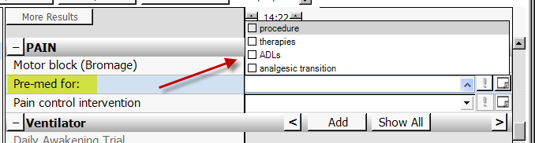
Added “absent” to the Abnormal Breath Sounds assessment drop-down list.
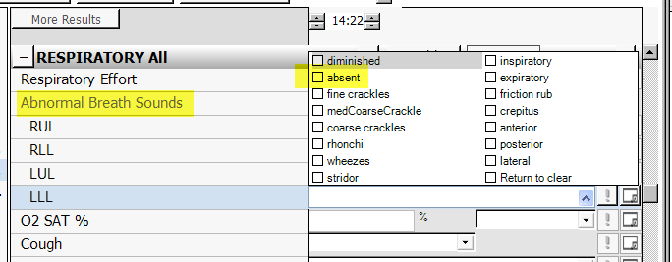
Added new result for “Flap Check Reassessment”
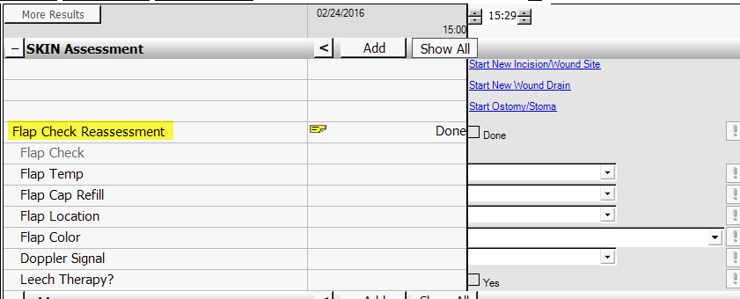

Modified HYGIENE/ADL Interventions result to be force display and ALL CAPS in the title. Moved to the first position on the Care Assistant 2 tab.
