For all VUMC:  
Added “Pt off unit” to Pain Assessment w/o scale drop-down.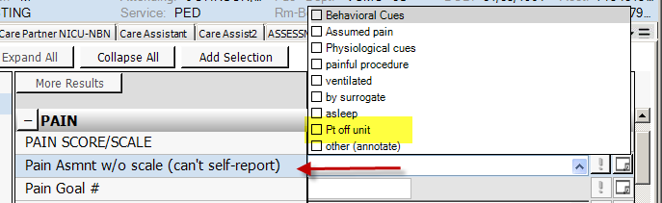

For VUH units using the PAINAD/Dementia results, added hover-over text to describe scoring requirements.  
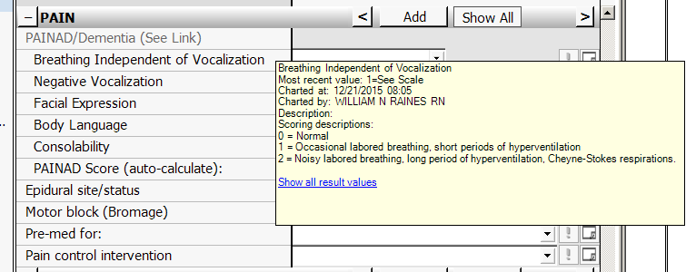

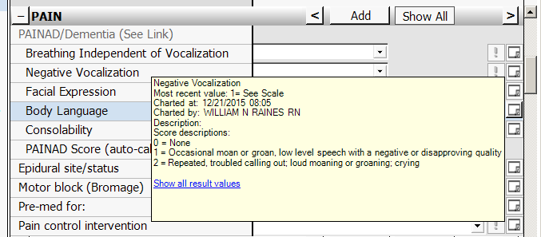

Please remember items **in ALL CAPS** are **REQUIRED** charting each shift. When charting a patient discharge in the EDUCATION tab, PLEASE collect an accurate phone number to be used for follow up phone calls. These calls are made by *outpatient nurses* but they depend on the inpatient, discharging nurse to collect an accurate number.

