For all VUMC. Added “Other” to HYGIENE/ADL interventions:  
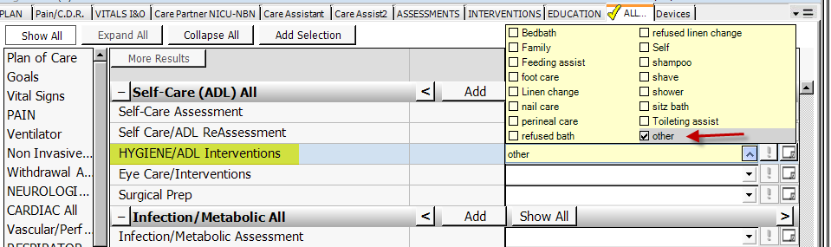

All nursing admission forms:  
Updated text for Chaplain/Pastor requests.  
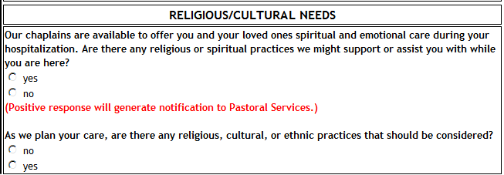

VUH, OB and VCH  
Addition of text instruction to not use “N/A” in Social Work comments.

