Added a link for VPH to the new “Modified COWS protocol”

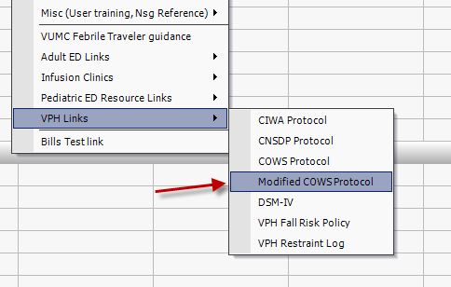

Correction to the redirection that occurs in the “More Web reports”. No screenshot, it will take you directly to the pages now.