For VCH only: New fields for Car Seat testing and Rooming In.  
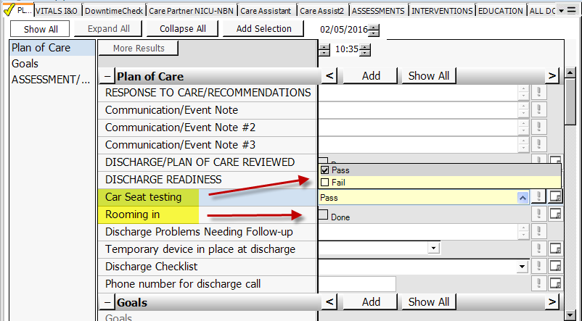

For all VUH: corrected link to Clinical Key nursing resources.   
