For VCH only. Modification to the Delivered/Demand documentation on the CDR tab.  
New fields for “Delivered” and “Demands” will automatically calculate the number of “Denied”. Fentanyl example. All drugs have the same type of entry.

Previous documentation will still be visible, but not chartable.  
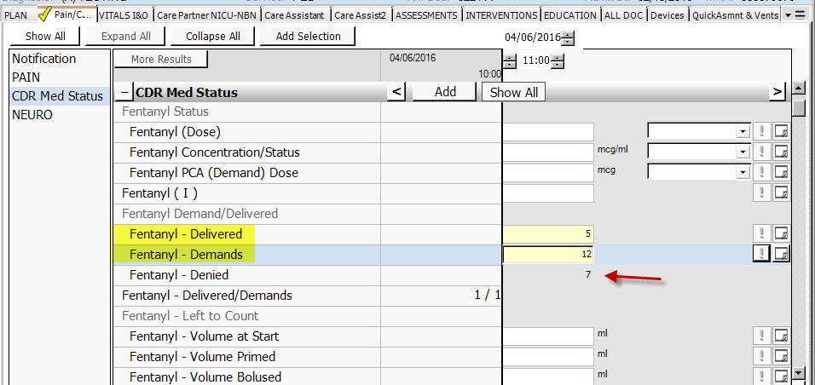

For all VUMC. Added “Other” to HYGIENE/ADL interventions:  
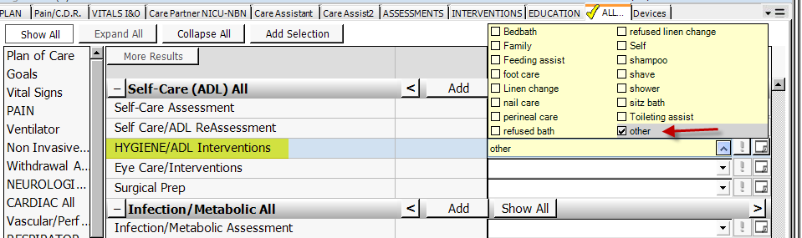

All nursing admission forms:  
Updated text for Chaplain/Pastor requests.  
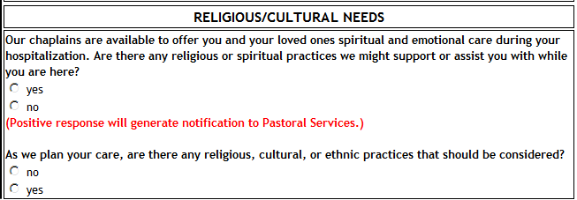

VUH, OB and VCH  
Addition of text instruction to not use “N/A” in Social Work comments.

