For All units that now use the new nursing documentation redesign
ALL DOCS and ASSESSMENT, Respiratory section > “Secretions” – “blood streaked” has been added to the dropdown list
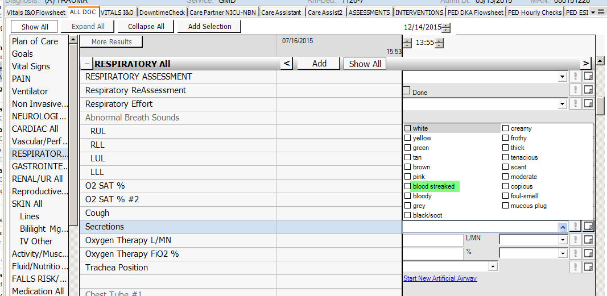

Pain section – “PAINAD Scale” has been added to the PAIN SCORE/SCALE dropdown list
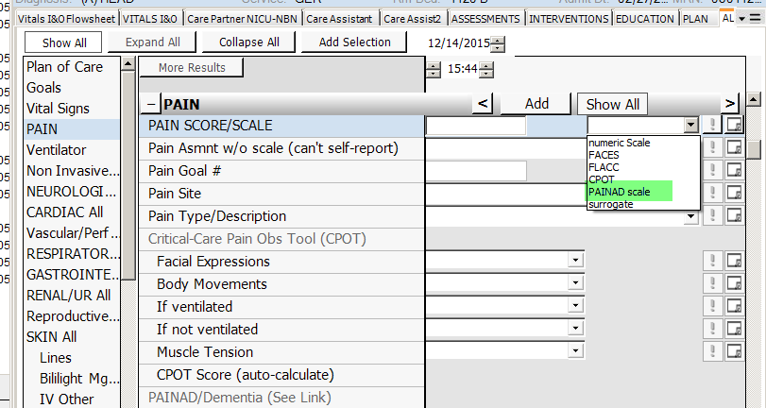
Pain section under Epidural site/status – WNL has been added to the dropdown list
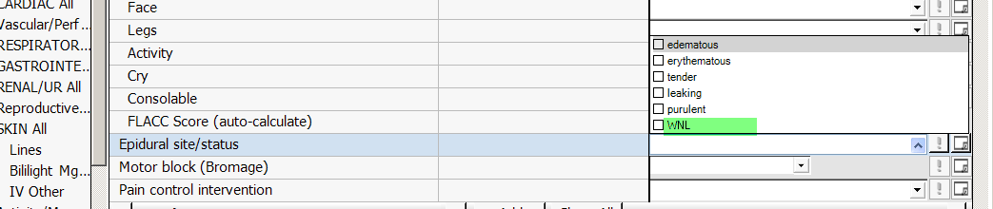
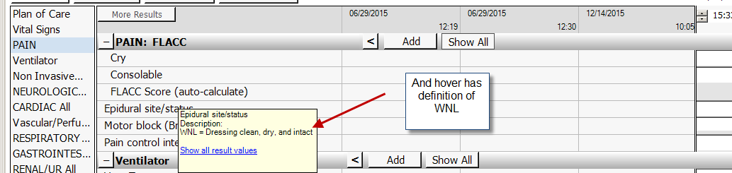

In GI section there have been updates to the GI tube template. In the One Time data, BCS and BMS have been added as an option for GI Tube Type:
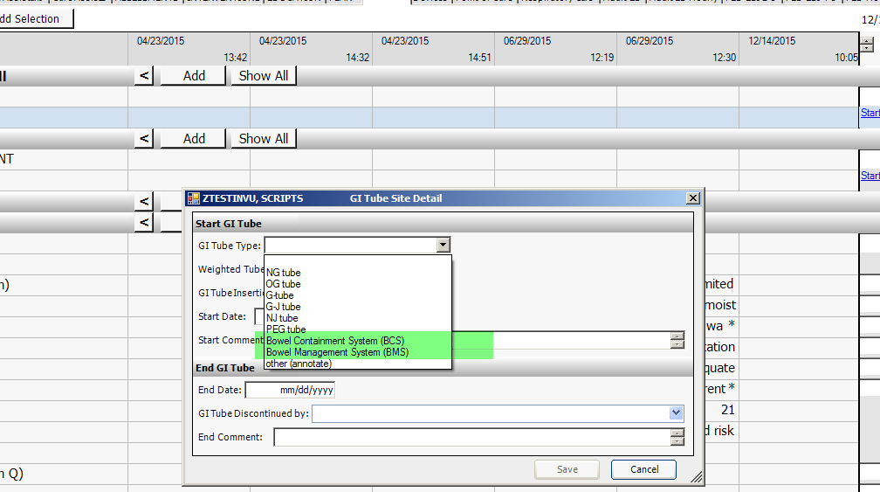

In the Trended data for GI tubes, new additions for GI Tube Interventions
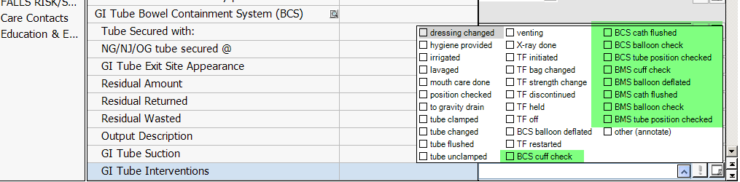
In the ALL DOCS and PLAN tabs under Respiratory Goals – new option in dropdown list for ‘pt will tolerate weaning of resp. support”
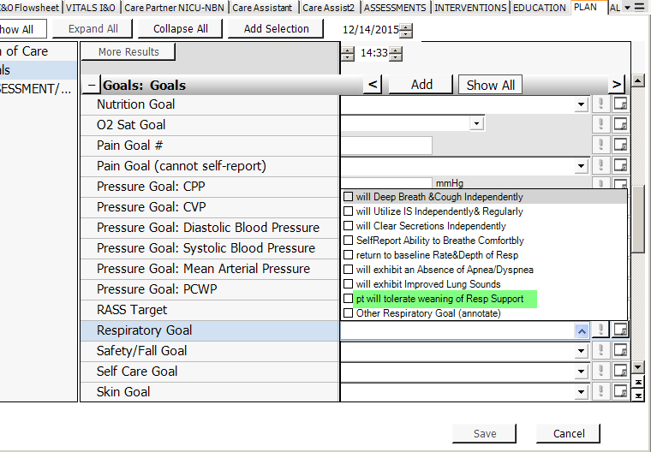

EDUCATION Tab > Education – New charting field added for Homeward Bound Class –
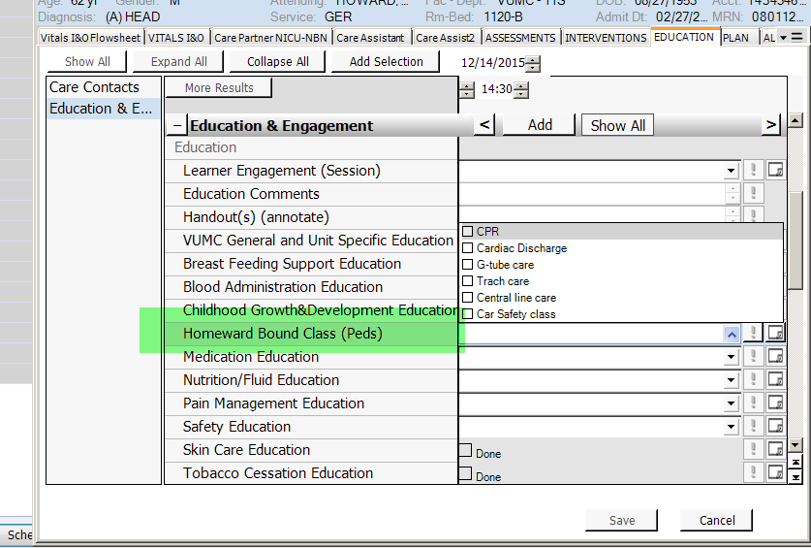
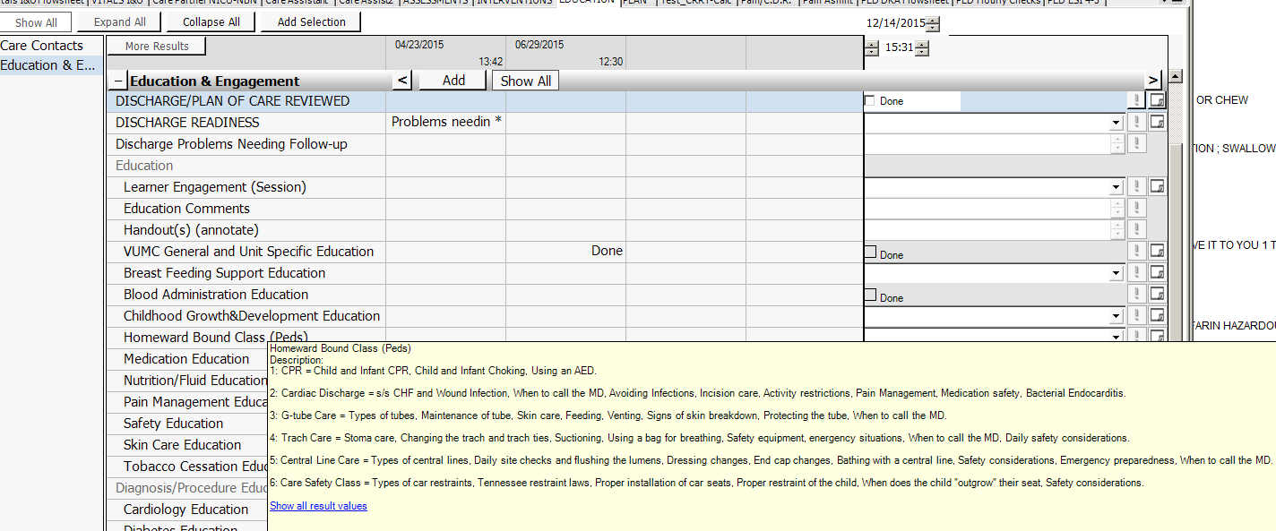

We have added links to the Adult ED chart menu
