For VUH and VCH
Blood Transfusion – the Cosign has changes to the display name. And the hover over description has also been modified. Also, Plasmanate is no longer chartable. Any Previous documentation will be viewable.
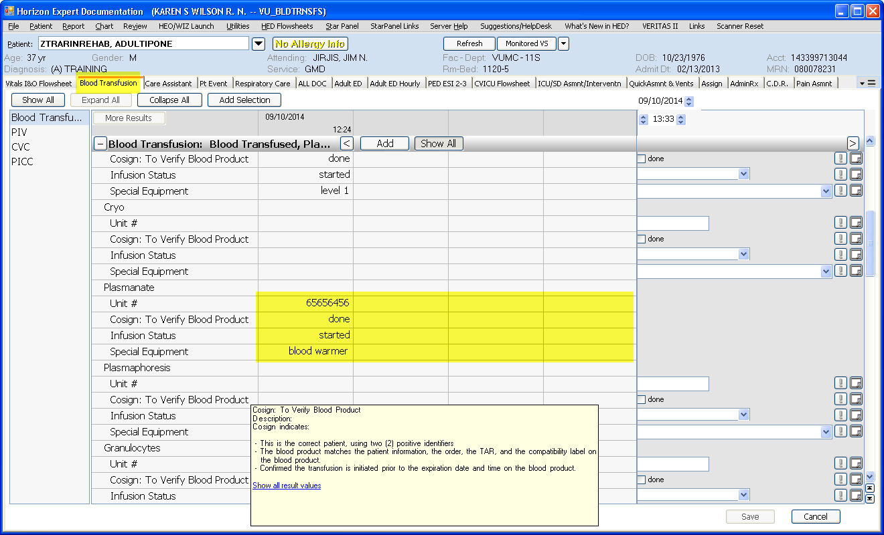
There has been a change in the Blood Administration Links. They will be found in the Misc (User training, Nsg References) >Blood Administration >with two options
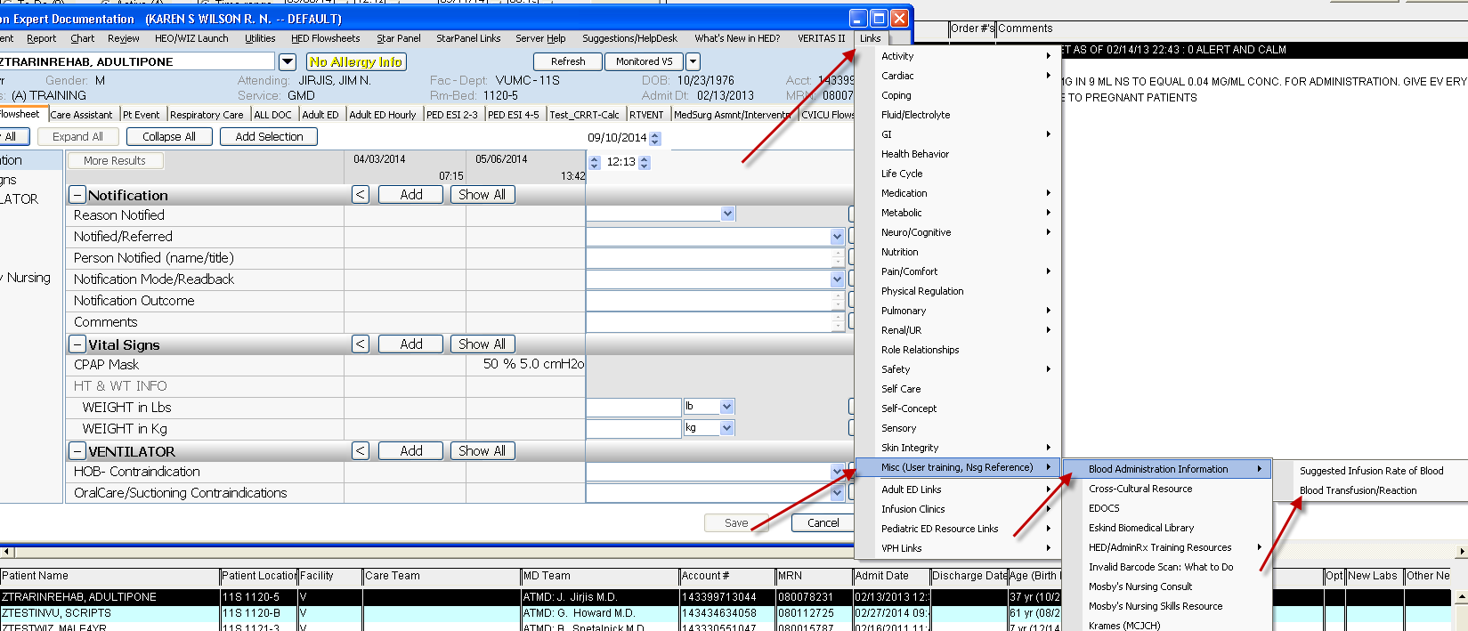
Which opens to
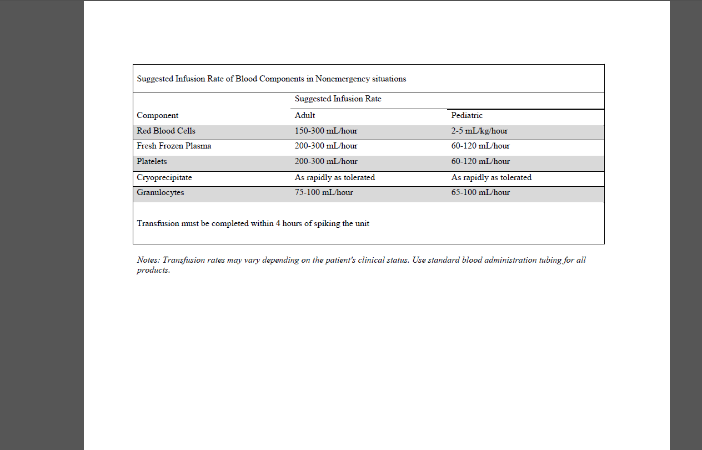

And
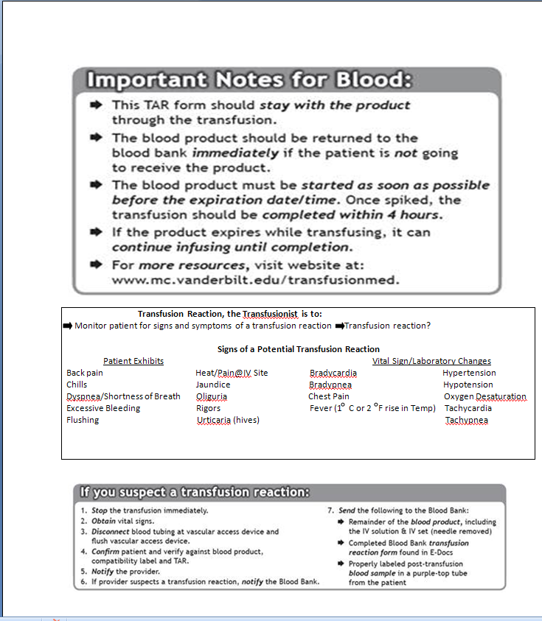

NICU & NBN
Newborn Nursery Flowsheet >Educ/Dschrg Plan -24hr after birth Pulse Ox check will no longer be chartable. Any previous charting will be visible. The display name for Discharge Pulse Ox check has been changed to “CCHD” with three new options in the dropdown list.
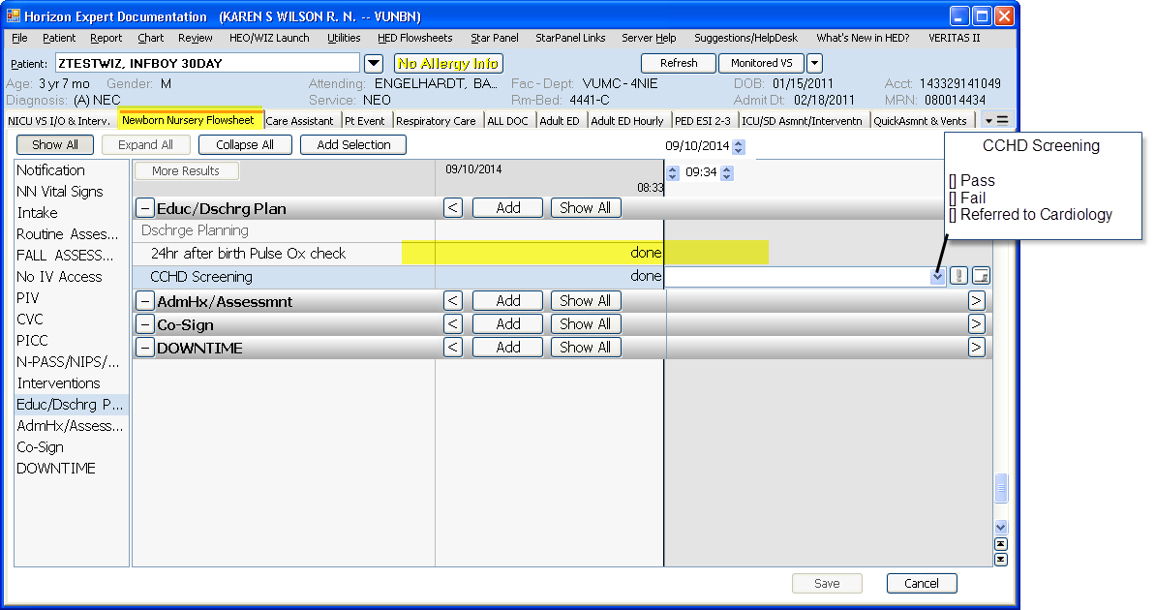
On the Plan of Care/Dschg Plan > DischrgePlanning – CCHD has been added
