For all VUMC
All Asmnt tabs, Vitals I&O tabs, and the Pain tab > Pain > Motor Block (Bromage) is now force display
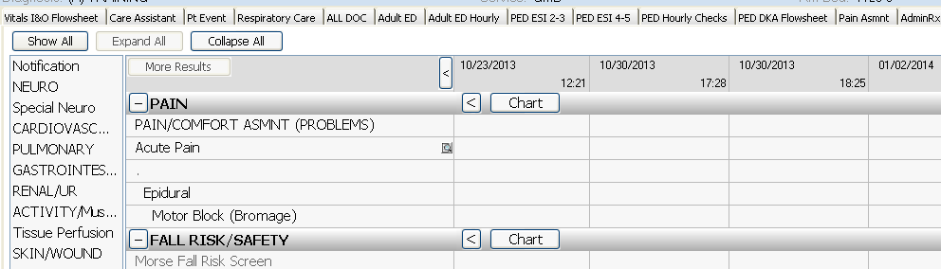

A new link has been added to the Medication links to assist the nurses with how to schedule skipped or staggered medication
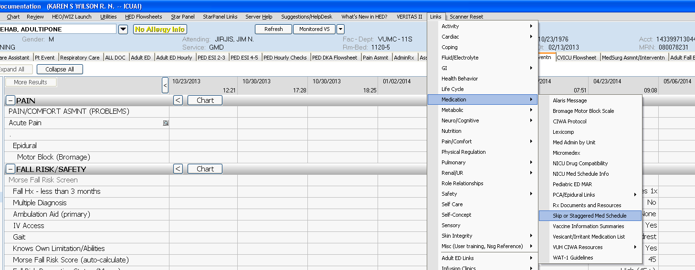

Vitals I&O Flowsheet > Vital Signs > CPAP Mask will no longer be chartable. Any old documentation will remain viewable. 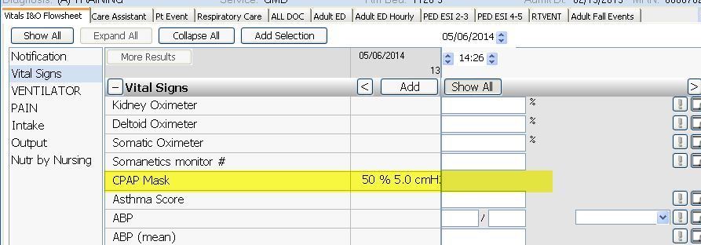
On Asmnt tab > Gastrointestinal and on the Peds ED and the EMER tabs> POC –
The Hemocult Testing and the Gastrocult Testing have been consolidated so that this documentation is shared across Peds and Adult. The old charting fields will no longer be chartable, but if there is previous documentation it will remain viewable.
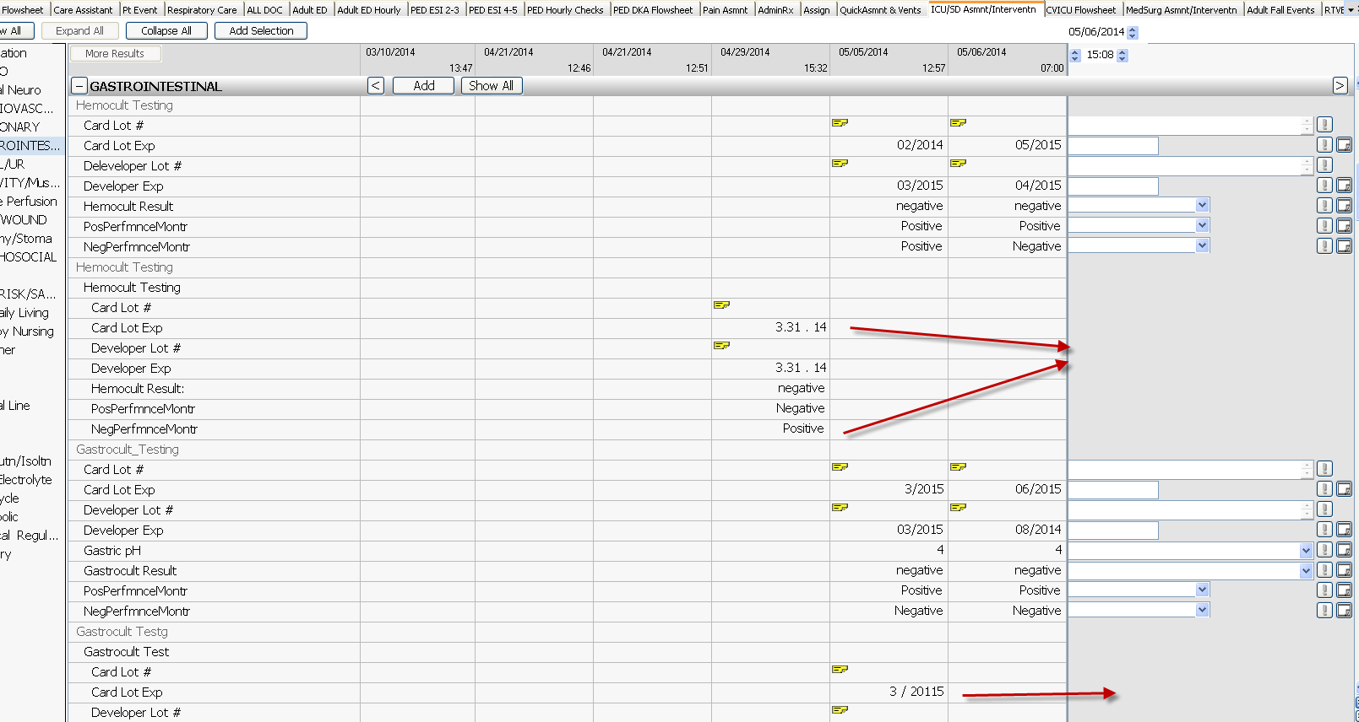

And the Care Assistant tab now has a new section “GI Testing POC” which contains the Hemocult and Gastrocult charting fields.
