**Changes for VUH and VCH**

1. Areas that will now see mixed case spelling rather than ALL CAPS are
2. Ventilator for VUH
3. Glasgow Coma Scale dropdown list will have all mixed case
4. Patient Preferred Language on Education tabs will no longer be in all cap
5. Pain/CDR tab -New charting fields are now available for CDR documentation (Methadone, Pentazocine, and B.A.D. syringes)

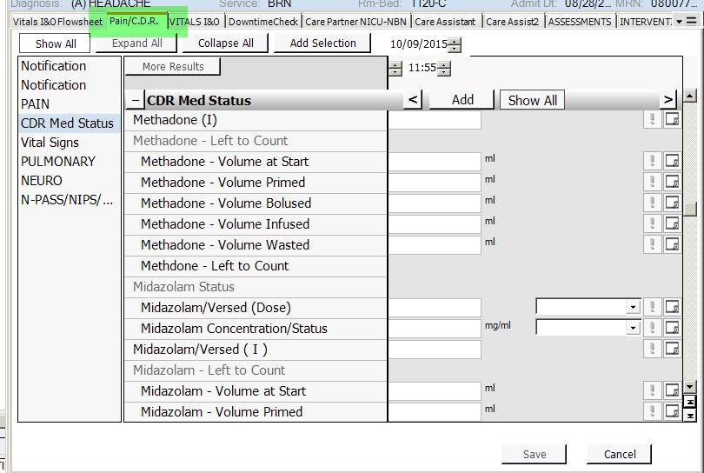

1. New fields built for PA Catheters and CV site. Previous documentation will be visible.  
   Will need to click “Show All” to see new fields. Documentation data is the same.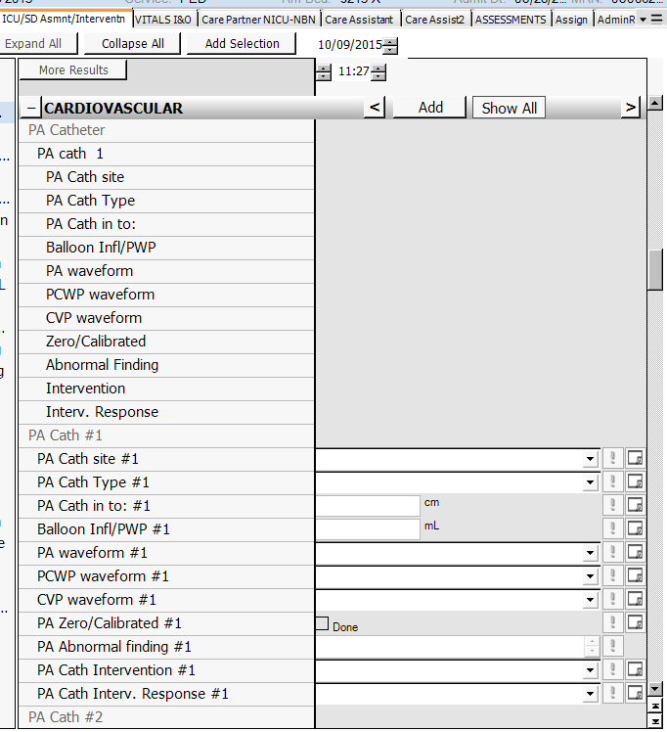

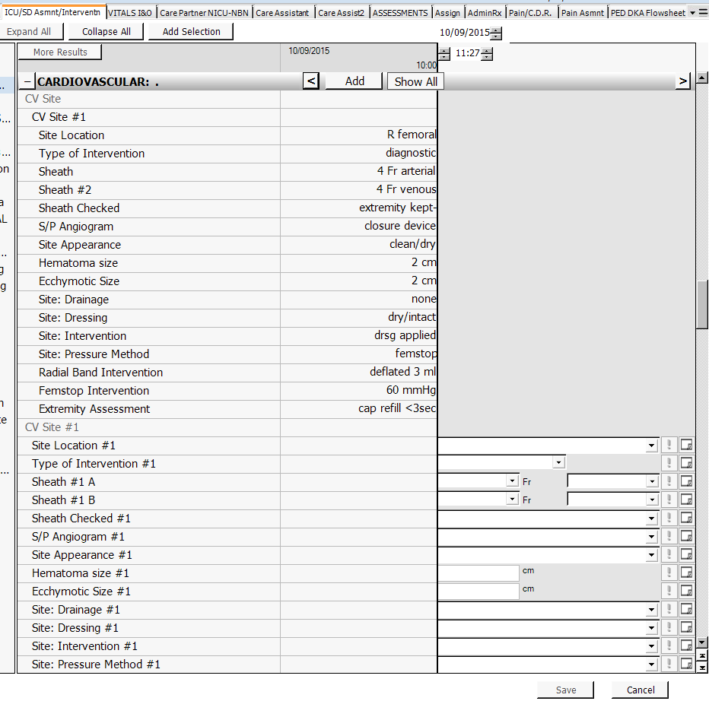

The charting field of “Previous IV site check date/time:” has been moved within the One-Time data of PIV from the PIV Removal section to the IV Infiltration Scale section

