For VUH, VPH, and VCH except NICU and NBN –
There is a new charting field for % of Food Intake. For units that are not up on the new nursing documentation redesign – This field will be replacing the old Food Intake fields in Nutrition by Nursing. Old charting fields will have previous documentation as viewable but no longer chartable.
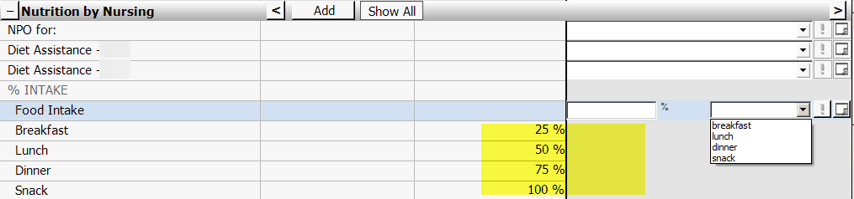

And the Nursing Documentation Redesign Units will be gaining this field on their ALL DOCS>Fluid Nutrition, ASSESSMENT>Fluid Nutrition, CareAssist2>Fluid/Nutrition, and VITALS I&O>Intakes
