On Tuesday, October 7th, the VUH inpatient whiteboards will display an “EstDC” column.

The column will display the Estimated Discharge information entered by the provider on either the Adult Internal Medicine Progress Note or the Dynamic Risk Profile Dashboard.

Sample Inpatient Whiteboard

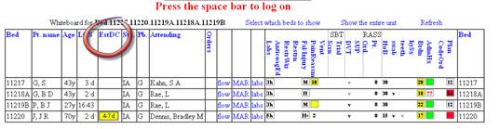

Sample EstDC data entry field

