The following changes are mainly for the Infusion Clinics but will be seen by all HED users
Changes to Lumen Intervention drop-downs for CVC and PICC.
CVC:
Removed “lab draw”;
added “Irrigation of implanted Port-a-Cath, Lab collected Central Venous Cath and Lab collect implanted cath/port
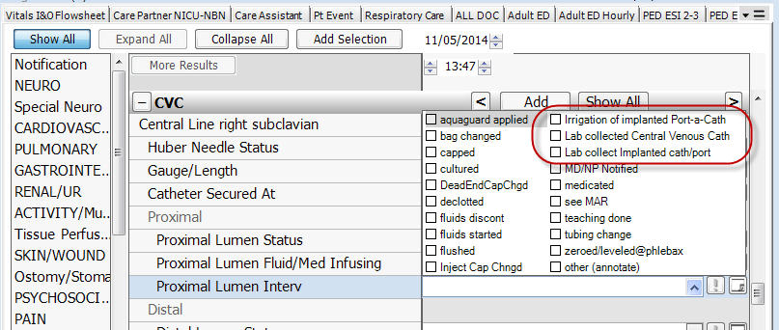
PICC:
Removed “lab draw”;
added Lab collected Central Venous Cath:
