NICU Care Partner Tab
Comment section added as last section
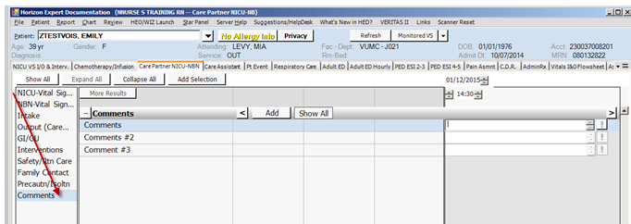

In the Output section, Emesis Output and Emesis Occurrence have been added:
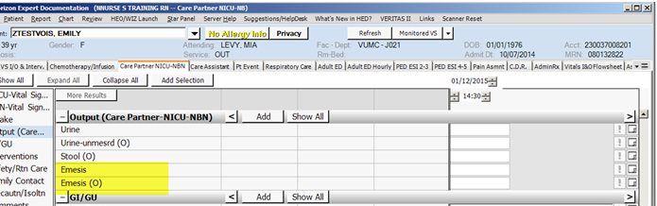

NICU-Vital Signs section – “Four Extremities BP”, “Transcutaneous Bilimeter” added:
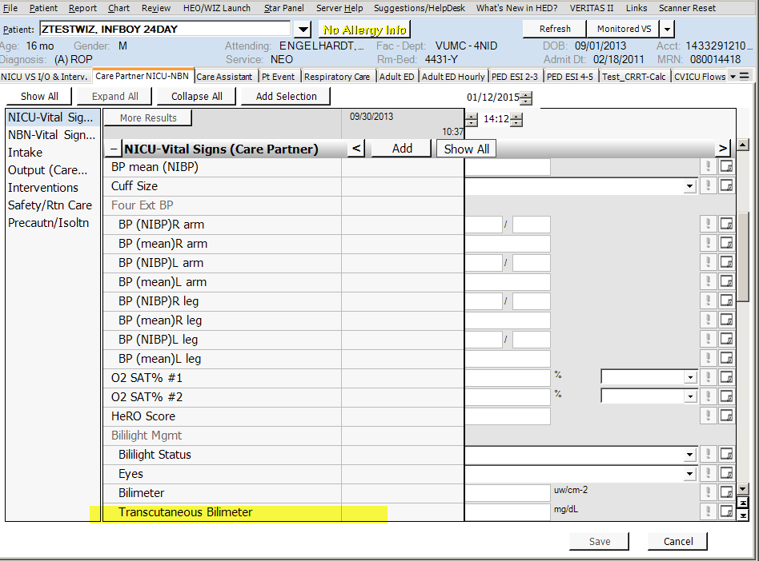

SideRails Up/ Isollette Latched and Safe Sleep added to Safety / Rtn Care
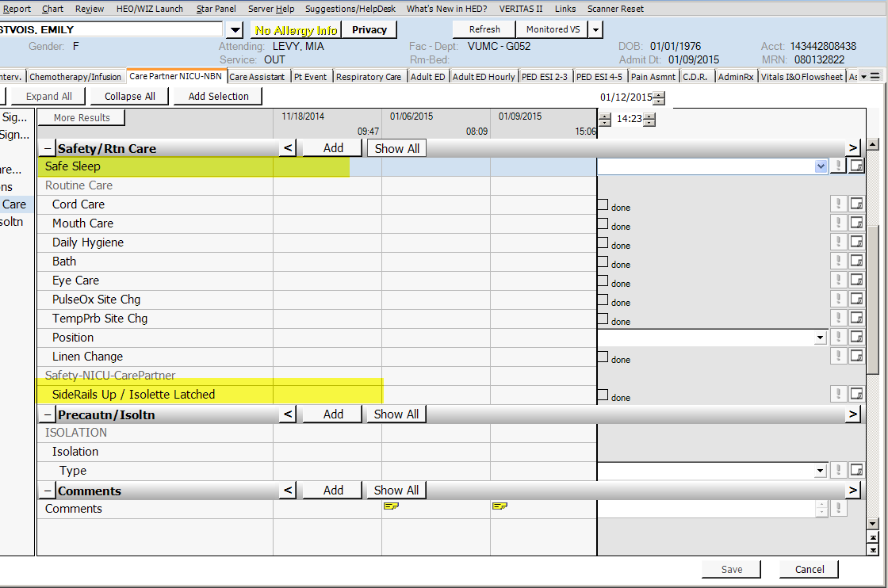

Feeding Interventions added to the GI/GU section.
