NBN Care Partner

Comment section added as last section:
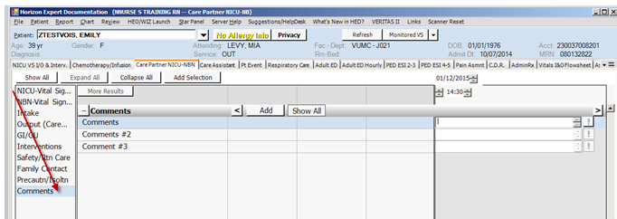

In the Output section, Emesis Output and Emesis Occurrence have been added:
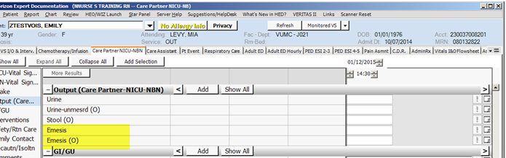

Vital Signs – fields added “Ambient Temp”, “BP (NIBP)”, “BP mean (NIBP)”, “Height/Length”, “Weight”, and “Head Circumference”:

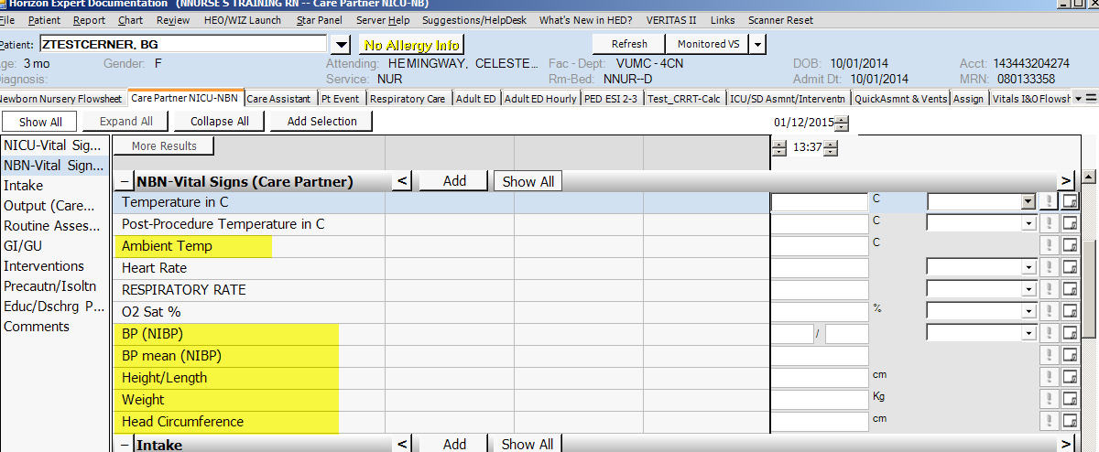

Safe Sleep, Siderails/Isolette Latched, and Breast Feeding sections added to the Intervention section:
