1. In response to customer feedback regarding challenges of documenting required elements for patients receiving PCA or epidural analgesia, we will be modifying the existing Pain Tab. It will be called the Pain/Sedation Tab and it will include “shared results” from several other tabs to enable the user to visualize all elements required for PCA/Epidural analgesia in one place. For example, vital signs documented either on this tab or on Vitals/I&O tab can be seen from either tab. The same is true of pulmonary assessments, RASS, and other Pain care category documentation. This will not replace documentation of controlled drugs on CDR as there are still elements on that paper document that are not available electronically.  Feedback from staff who have been involved in designing this new tab think this will support increased compliance with pain relief documentation according to policy and make it quicker and simpler at the same time. To provide additional guidance, there will be quick access to relevant policies available under LINKS, Medications. These policies include documentation requirements for Epidural and PCA analgesia.  There are future plans to add content about documentation of Light Sedation and you will get more information about that when those changes are ready to release.

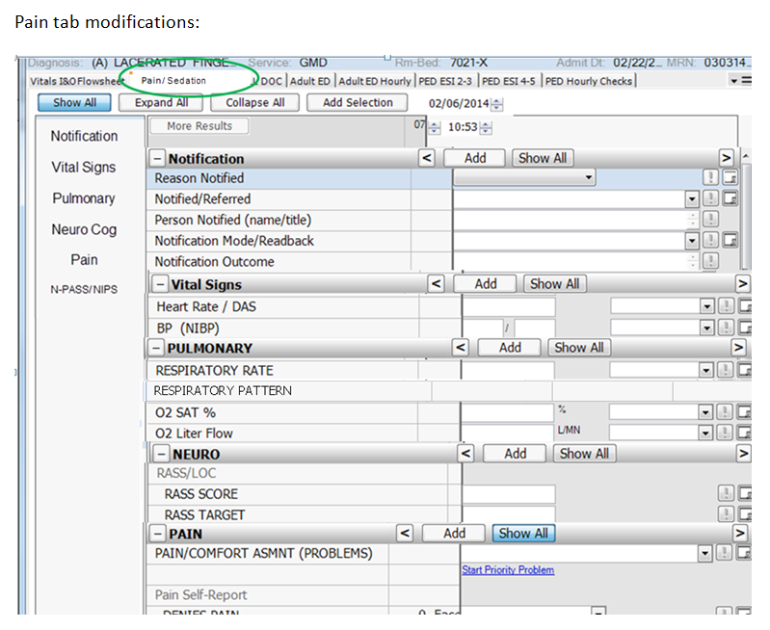

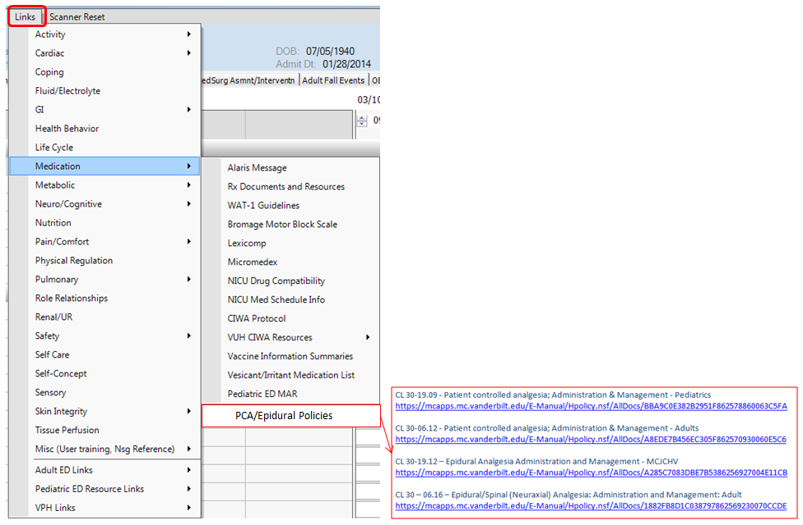

1. Beginning with revisions to documentation for Wound and Skin implemented a few weeks ago, work was started on changes to documentation of Ostomies and that work is now ready for release. This format will eliminate some of the scrolling required to document about ostomies. If the patient presents on admission with an ostomy, enter the day of admission as the start date and check the present on admission box. If the ostomy is started during hospitalization, then the actual date the ostomy is created would be used. In most cases, an Ostomy would not be ended but if a temporary ostomy was reversed, there is a place to document ending the site. Start and End comments are optional.

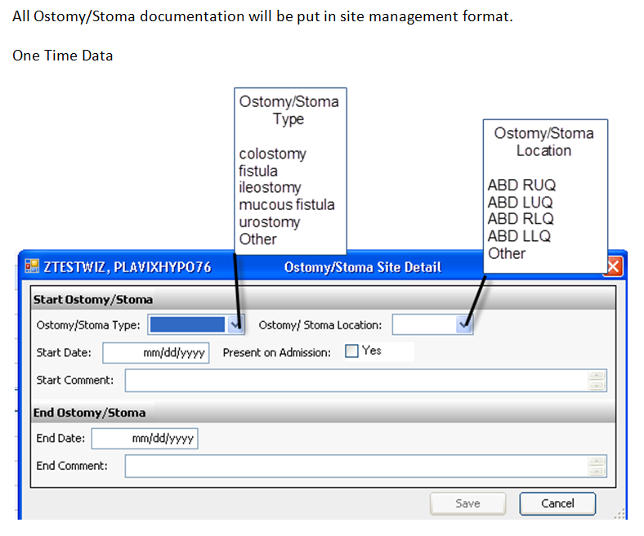

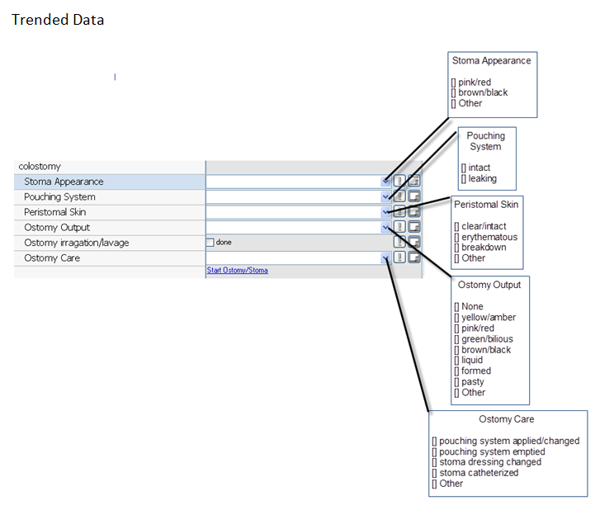

1. Many of you have noticed the recent change to require number of “sticks” when documenting peripheral IV (PIV) insertions. This change was made in response to quality concerns brought forward by the Adult and Pediatric IV Teams. The attached document includes a brief summary of rationale for this change. We have had some concerns raised about this change so will be making one alteration to PIV documentation Mar. 18. At that time, the current “numeric entry” box will be changed to a drop down list that will now include the option “unknown”. If documentation of a PIV is started in HED for a PIV that was inserted prior to the time the patient arrived on the unit, number of attempts would be “unknown”. Otherwise, the person documenting the new IV would document the number of sticks s/he made when inserting the new PIV. Attempts made by others would NOT be documented in this space.

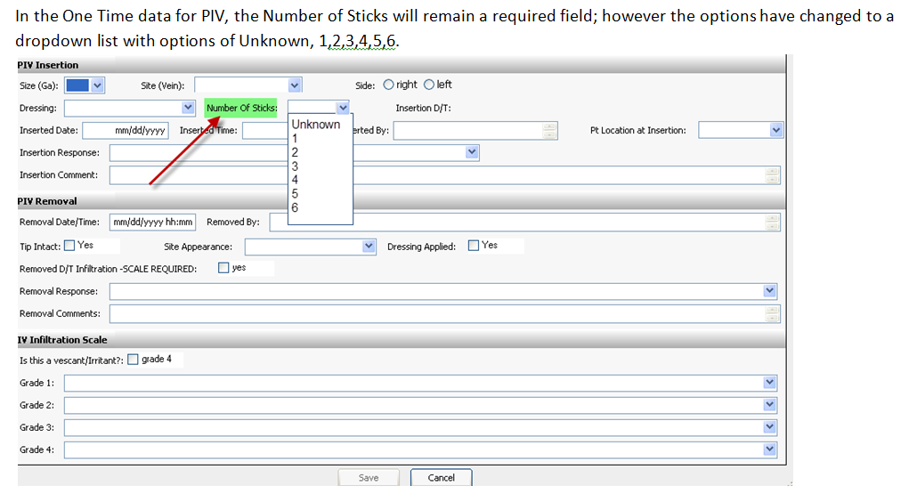

Unsuccessful attempts to start PIVs would be documented by the person who makes the unsuccessful attempt in the No IV Access section right about PIV section. (You would probably have to hit Show All to see this section and charting option for unsuccessful attempts. ) The drop-down list includes options to document up to 3 unsuccessful attempts by an individual. (Note that policy is that no one individual would make more than 2 attempts.)

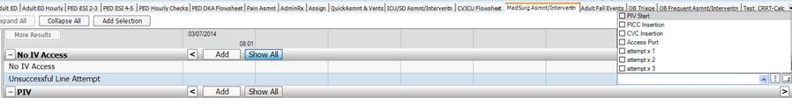

If there are questions or concerns about this issue, we encourage you to contact Cathy Perry, Mgr. of the Adult IV Team or Vicki Jones, Mgr. of the Pediatric IV Team.