For All VUMC
Assessment tabs> Skin> Incision/Wound Templates> There will now be an place to chart “Present on Admission” in the One Time/New Wound section
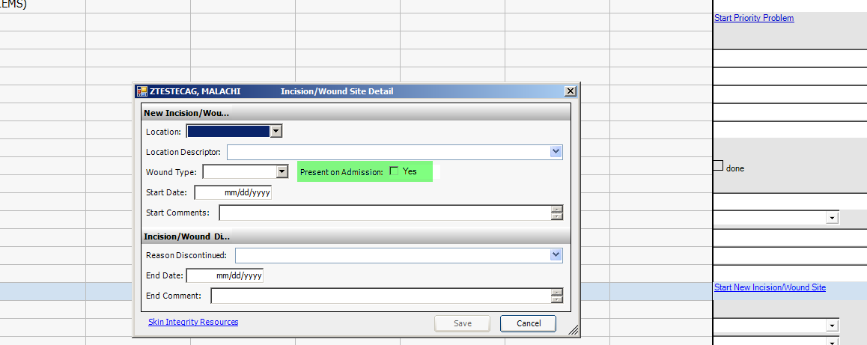

Links> There are now two option to locate PUP and PU Intervention Resources
- Directly under Skin Integrity
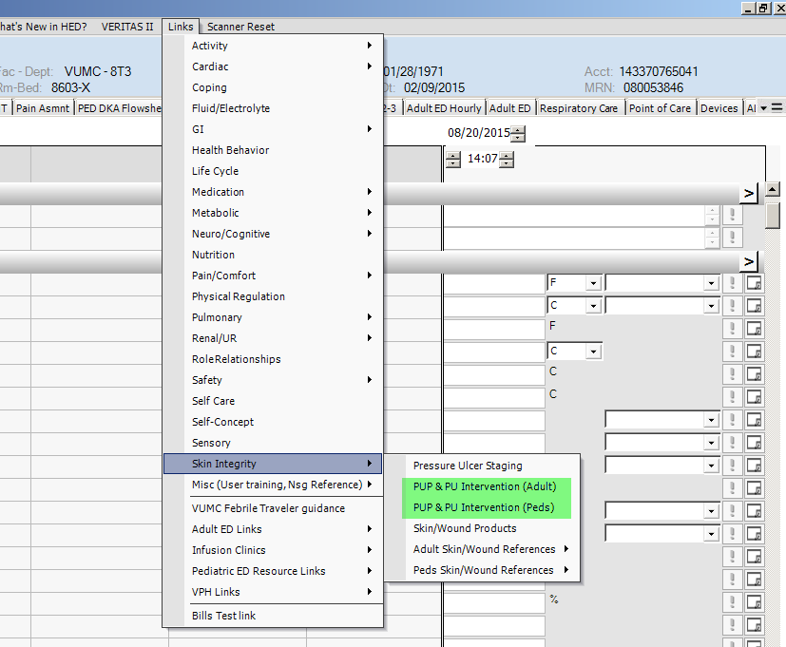
- Or under either the Adult Skin/Wound References or the Peds Skin/Wound References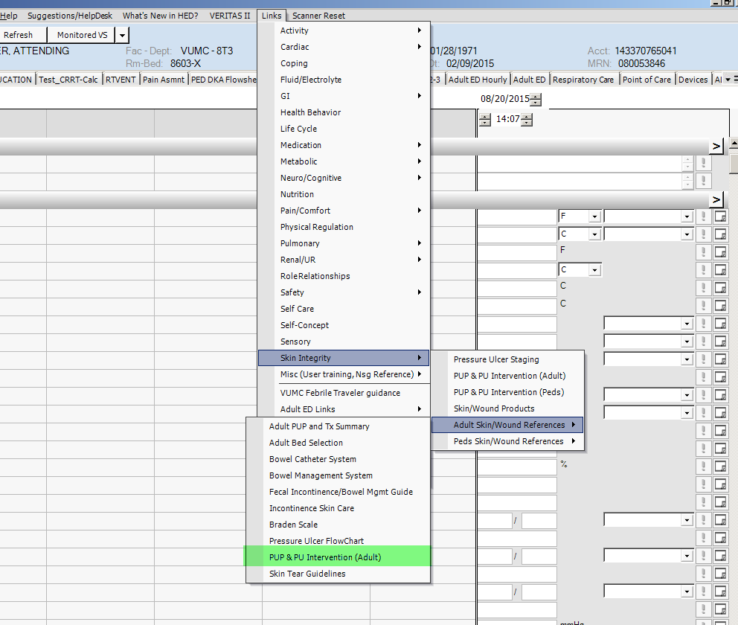

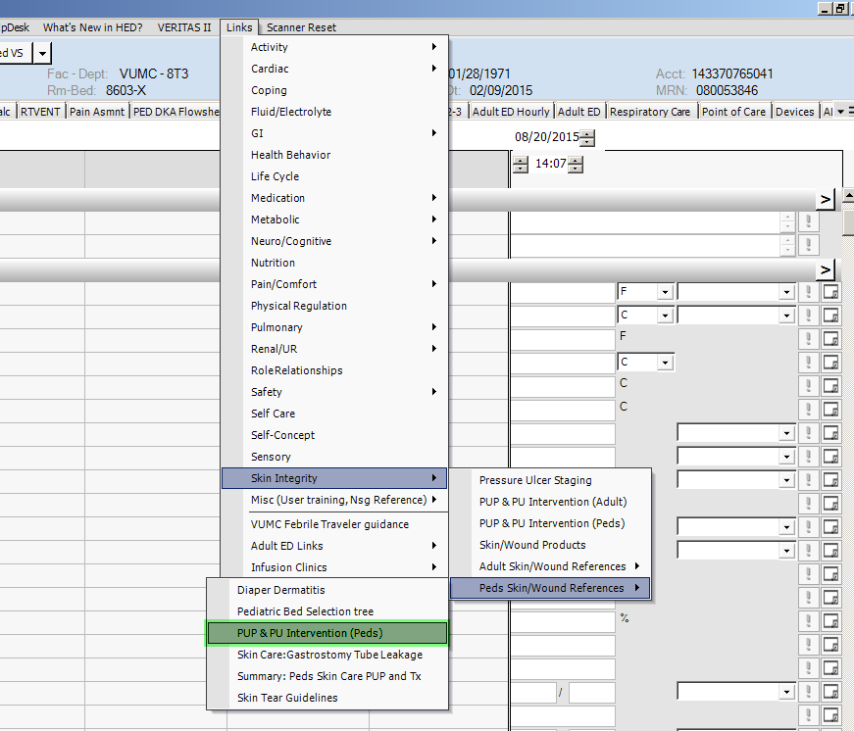

Asmnts> FALLS RISK/SAFETY section>for restraints> the dropdown list has changed. The new options will be “initiated”, “continued”, or “discontinued”
