For Adult ICU’s (10N, 11S, 5N, 6T3, 8T3, 9T3)
Asmtnt/Intervention> FALL RISK/SAFETY>There is a new option in the Falls Risk section for “Pt Incapable of Moving”, as well as an option for “Low – pt incapable of Moving in the Fall Risk Precaution Status (Morse) dropdown list.
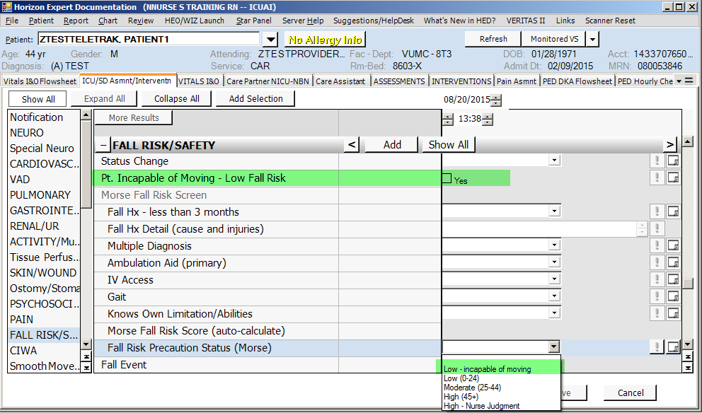

Assessment> Pain> the Adult ICU units will now have new tool for Critical Care Pain Obs Tool section
