New Links are available for references for Lidocaine Infusion for pain management
Links>Medication>Lidocaine Infusion -
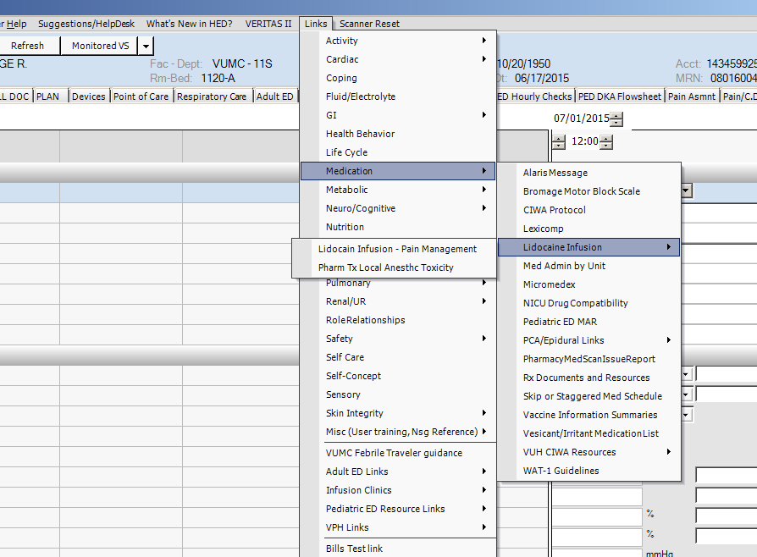

For ICU > Assessments>VAD>
We added new fields for HeartMate III
