For VUH only: New BMI calculations:
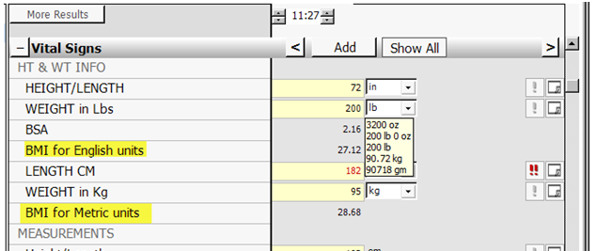
And a link to the CDC BMI resource page:
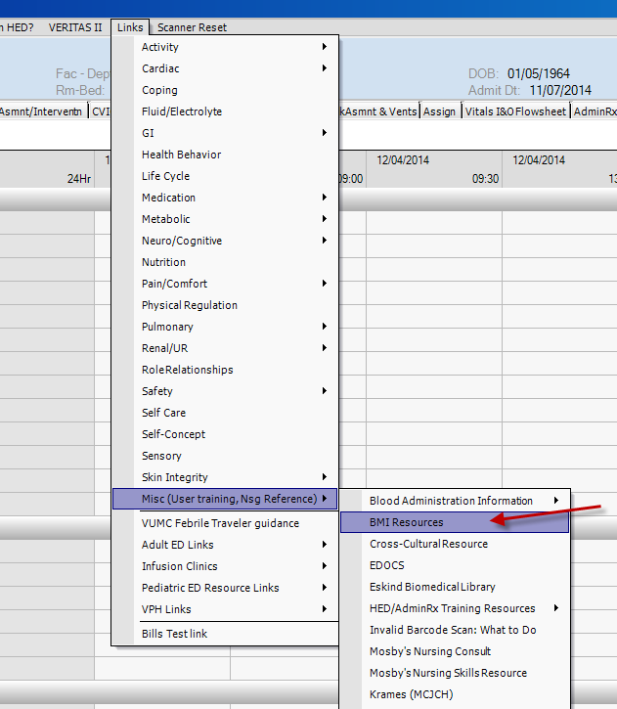
AdminRx results for Meningococcal vaccine administration. This information will flow to the StarPanel Immunization Record:
